Diverse History

Teaching
for Creativity Taster Cards
Quick challenges to practise creative habits

The Five Creative Habits of Mind

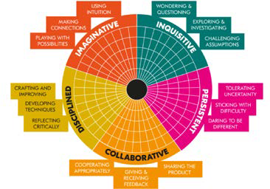
A New Direction, like many others, believes that creativity can be taught, and we want to support schools and teachers to feel equipped to do just this.

The pedagogies underpinning our Teaching for Creativity work come from the five Creative Habits of Mind – a concept developed from decades of research by Bill Lucas and colleagues which has now been widely adopted into learning policies across the globe. The Creative Habits of Mind are a great tool for tracking the development of your students’ creativity.

To find out more, visit: anewdirection.org.uk/teaching-for-creativity

How to use these cards
These Taster Cards can be used as ice breakers, starter activities, class assembly prompts, ways to start and end the day, or as stand-alone 10–15-minute activities.

They are suitable for all settings, and they can be adapted for any age or level.

They were developed in partnership with Royal Museums Greenwich, Migration Museum, and Foundling Museum. Each museum was tasked with choosing items from their collections as inspiration for a short activity related to a creative habit.

They are designed to be used in the classroom, but we also encourage you to visit the museums in person.

This set includes some general tips and ideas for each of the five habits, in addition to activity cards. You can also find information about the museums and the items they have chosen.

We hope this resource helps you to think about how to use pedagogies for the 5 creative habits of mind across the curriculum.

Migration Museum

Who are we?

The Migration Museum explores how the movement of people to and from Britain across the ages has shaped who we are – as individuals, as communities, and as a nation.

Migration is a pressing contemporary issue and is at the centre of polarised political and online debate. But there’s an underlying story of comings and goings stretching back many
centuries. And this story goes to the heart of who we are today. Britain has thousands of museums, but unlike many other countries, from Australia to France, Brazil to the USA, we don’t have a permanent Migration Museum. The time is right for a highly relevant, accessible visitor attraction that shines a light on who we are, where we come from and where we are going. We stage engaging exhibitions and dynamic events, alongside a far-reaching education programme for primary, secondary, university and adult learners.

If you would like to know more about the work the Migration Museum does, you can visit our website at www. migrationmuseum.org or visit our current home in Lewisham Shopping Centre.
Getting Started

Althea McNish
Althea McNish was a textile designer who migrated to the UK from Trinidad as part of the Windrush generation. Amongst the many stories of the contributions these people made, particularly to the NHS and public transport system, Althea’s story focuses on the culture that migrants bring to a new country. Her
designs drew heavy inspiration from the natural landscape that surrounded her in England, melded with the memories and colourful artistic style she brought with her from the Caribbean.

Althea’s story is shown in the Migration Museum’s ‘Taking Care of Business’ exhibition which tells the story of some of the Migrant entrepreneurs who have transformed aspects of British life over time, from the hyper-local to national.

100 Images of Migration

The Migration Museum’s first exhibition was called 100 Images of Migration, involving a public call-out for pictures associated with the word ‘migration’. A wide range of photos from various time periods were submitted, giving glimpses of a diverse range of cultures and histories. Each image in the exhibition leaves us to investigate the depth and intrigues of the story being displayed, and the myriad of voices and perspectives of all the people who shared their picture.

This particular image is by photographer, Tim Smith, and shows an aspect of migration and the culture of those with migrant heritage.

Getting Started

Place and Pattern
- Before the lesson, find some examples of Althea McNish’s work on the internet and choose a selection to display to pupils.

- Share the Althea McNish patterns between pupils so everyone can see them.

- Pupils will each need colouring pencils or pens and an A6 sheet of paper (or A4 cut into thirds).

- They close their eyes for 20 seconds and imagine a place that is special to them.

- In just 10 minutes, pupils are tasked with creating a pattern that is inspired by that special place. Invite pupils to think in the abstract or to just take an element or feeling of that location.

- Once pupils have completed the activity, invite volunteers to share their design with the class, and explain their process and the place itself.

Reflection
  - What places did we have in common between us?
  - Did we pick different locations but for the same reason?
  - What did that imaginative process feel like?
  - What did you find was a challenge? Or simple?

Go Further
Create a class exhibition of the work. Visit the Migration Museum in Lewisham to see the work of collagist Hormazd Narielwalla who was also inspired by Althea McNish, or to look at Karen Arthur’s dress and the different places and periods that inspired her artwork.

Imaginative: Using Intuition
This activity asks students to practise tuning into how an artwork makes them feel, drawing on memories and places that are special to them – encouraging them to make connections without analytical thinking.

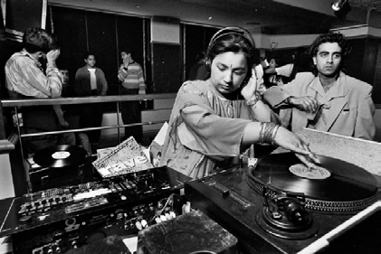What’s the Story Here?
- Display the photograph to the class without sharing the caption.

- In pairs, pupils explore the following questions together:

  - What do you think the story behind this image might be?
  - What does the word ‘migration’ mean to you?
  - Why do you think this photograph was chosen as an image that represents migration?
  - How would you choose to represent migration in just one image?

- Each pair shares with the class their idea for an image.

- Now read the actual photograph caption together.

Photo © Tim Smith
Reflection:
- How did our interpretations match with the actual description?
- What led us to think what we did about the image?
- How did it feel working together with a partner in that activity?
- What kind of strengths did you find in that quick collaboration?

Go further: Take a look at the other images in the exhibition and ask pupils which images capture their attention and why. Using these
images as inspiration, task pupils in small groups to draw, photograph or create a freeze frame of an image that they feel represents migration.
The DJ Radical Sista hosting a ‘day timer’ in a Bradford nightclub during the heydey of these music events in the 1990s. Day-timers were held in the afternoons for Asian teenagers who were often not allowed out during the evenings.

Collaboratively: Co-operating Appropriately
Pupils use their own imaginations and opinions but collaborate together contributing and sharing their ideas, making sure they take turns. They work on building their confidence to share ideas that are important to them.

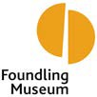The Foundling Museum
Who are we?

The Foundling Museum tells the story of the Foundling Hospital, the UK’s first children’s charity and public art gallery. In 1739, Thomas Coram created the Foundling Hospital to care for and educate children at risk of abandonment, whose mothers were unable to look after them.

Setting up the Hospital was no easy task and Coram campaigned for 17 years before King George II finally signed the Royal Charter granting his permission for the Hospital to open.
In the 1920s, the Hospital moved to the countryside and the London building was largely demolished. Over two centuries until its last residential pupil in 1954, the Foundling Hospital looked after around 25,000 children.

In the 1930s, a new building was built on the site of the former Foundling Hospital at 40 Brunswick Square. In 2004, this opened as the Foundling Museum.
Tokens

Between the 1740s and 1760s, mothers leaving their babies at the Foundling Hospital would also leave a small object to prove their relationship with their child in case they were ever able to return to the Hospital and take their child back. These objects are referred to as tokens.
Mothers didn’t bring their children to the Foundling Hospital because they didn’t love them, but because they couldn’t look after them, often as they were too poor to care for them properly or because they weren’t married.
Children brought up in the care of the Hospital never saw their tokens.
Getting Started

N.B. Activities relating to the tokens may raise possible sensitivities for adopted children or looked after children in your class. Depending on your class, you might find it helpful to explain that the mothers who brought their children to the hospital often did so out of a concern that they could not safely look after the children, and that the tokens are a sign of their continued love and hope in spite of these circumstances.

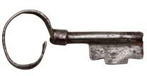
Precious One
- Show the class images of the three tokens.

- Ask pupils to think about what each of the tokens are and why they might be on display in a museum.

- Read the information provided on the Foundling Museum Tokens Card as a whole class.

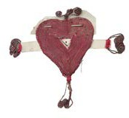
- Split the class into smaller groups and ask them to explore which token they think is the most precious and why.

- Ask each group to feedback what they decided and reflect on their debate. You can reveal that there is no right or wrong answer!

Reflection:
  - Were you surprised to hear some of the other opinions in the room?
  - Did anyone’s view make you change your mind or feel differently about the tokens?
  - How was your definition of ‘precious’ similar or different to the other groups?
  - What makes an object precious?

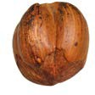
Go Further: Think about a possession of yours. Make a drawing of it and annotate the drawing with what makes it precious to you.
Consider where it came from – did someone give it you, did you buy it or find it? Think about what it looks like and what it’s made of.
Would your object be as precious to your friend as it is to you? Why or why not?

Inquisitive: Wondering and Questioning
This activity encourages students to challenge conclusions and look for evidence to support claims.

- Handmade paper and textile heart:

This token is made up of lots of different pieces and materials. How do you think the token was put together? Which bit do you think was made first?

There is a slip of paper pinned to the heart with the name ‘William’ written on it. Who do you think William was?

This token was made using a technique called embroidery. This was a slow and skilled process. Imagine the person who made this token. Who were they? What were they like?

- The key:
  - What do you think this key might have opened? Think about its practical uses.
  - Where do you think the lock to the key might be?
  - Do you think the key might have also had symbolic value to the mother who gave it? What might the key symbolise?

- The hazelnut:
  - Where do you think this nut came from?
  - Why do you think this mother chose to leave this nut with her child?
  - This hazelnut has been pierced for a string or cord – why do you think this is?
Token Tales Information Card

Token Tales
- Split the class into three groups and assign each group one of the three tokens. Explain that the stories behind these tokens have been lost.

- Ask each group to write one paragraph, imagining the story of the object they’ve been given, using the images and questions on the Token Tales Card to help them.

- Come back together as a whole class and encourage each group to read out what they have created so far.

Reflection:
How did it feel to invent a story about an object that we may never know the real history of?
What did it make you think about the person who gave the object and their relationship with their child?

Go Further:
As a class, decide how to link the three stories together into one story, using linking words to connect the tales of the different tokens. You could ask one person from each group to stand up and physically order themselves in a line instructed by the rest of the group.

Extra information: In folk tradition, hazelnuts were associated with wisdom, and hazel trees were also believed to offer protection from evil.

Imaginative: Playing with Possibilities
Students use the tokens as a starting point to imagine different possibilities for the stories behind them, collaborating in small groups, and sharing their ideas with others.

Getting Started
Yinka Shonibare’s Trumpet Boy

‘Trumpet Boy’ is a fibreglass mannequin of a child dressed in a Victorian-style suit playing a cornet and was created by London-based contemporary artist Yinka Shonibare.

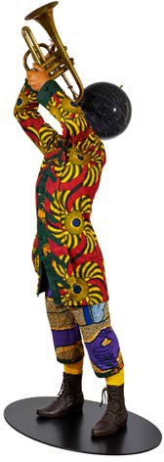
Yinka Shonibare CBE, Trumpet Boy, 2010 © Courtesy of the artist.

Bringing a Sculpture to life
What are you wearing?

  - Show your class the Yinka Shonibare’s Trumpet Boy card.

  - Split the class into smaller groups and discuss what movements and sounds the boy would make if he came to life.

  - Ask each group to create a short 30-second performance using your body, movement and sound to share with the rest of the class.

  - After everyone has performed, reflect as a class;
    - Have you ever thought about sculpture in this way before?
    - Would you ever do this activity in a gallery or museum?
    - Why or why not?

Reflection: How did it feel to watch the performances and listen to other people’s ideas? What did you enjoy the most about this activity and why?

Go Further: On the globe (the boy’s head), the stars have been replaced with names of famous musicians, especially those of African origin like Louis Armstrong. Listen to ‘What a Wonderful World’, then discuss as a class why Shonibare might have chosen to replace the names of stars with African musicians.

Collaborative: Sharing the Product

Students practice performance as a way of sharing a creative product, bringing their own ideas to an existing piece of work and trying out how to use movement and sound to convey ideas.
- Ask everyone to look closely at the fabric the boy is wearing on Yinka Shonibare’s Trumpet Boy card. Ask them to make some
drawings of the patterns they can see and write down which country they think the fabric is from.

- Reveal that the fabric is influenced by Indonesian design, made in Belgium and sold to an African market, but it was actually bought by Shonibare in Brixton. Shonibare says: “I like the fact that something seen as being African is actually the product of quite complex cultural relationships.’’

- In smaller groups, ask your pupils to think about where their own clothes come from and what influences what they wear. E.g. Family, tradition, trends, friends.

- Share these ideas as a whole class.

Reflection: Multiculturalism is about lots of cultures and identities mixing together. Do you think this is important and why?

Go Further: Organise a self-led visit to the Museum by emailing learning@foundlingmuseum.org.uk

What happens to your view of the fabric when you change your position/angle/stance? e.g crouching down and looking up, standing behind the boy, standing on the stairs and looking down. On a piece of paper, draw what you can see from each of these positions.

Inquisitive: Challenging Assumptions
Through discussion students build on others’ ideas, develop their critical thinking, and start to challenge opinions - or have their own assumptions challenged.

Royal Museum Greenwich
Getting Started

Who are we?

At Royal Museums Greenwich (RMG) we are explorers of time, space, place and belonging. Our collections and
subjects are about investigating worlds, crossing boundaries, bridging cultures and creating connections. We are a place to explore the very essence of what makes us human.

RMG is made up for four sites; the National Maritime Museum, historic ship Cutty Sark, the Royal Observatory Greenwich and the Queen’s House. The Museum’s collection comprises more than 3 million items, which include ship models and scientific, timekeeping and navigational instruments. Our collections reach across continents, cultures, tumultuous seas and cosmic voids. Through our institution, we have a uniquely interdisciplinary potential – art, history and science – which we can tackle separately and in dialogue with each other. We strive to foster inclusion and equality, representing diversity to be a place of and for opportunity, to
support wellbeing and to encourage active citizens.
Muhammed Muqim al-Yazdi’s Astrolabe

Astrolabes were beautiful models of the universe, representing the stars that could be seen in the night sky. Although they were originally developed in Ancient Greece, hence their name meaning Star-Taking when translated from Ancient Greek, they were heavily developed and used during the Medieval Islamic world. It was these Ancient Islamic scholars who built on the Greek design and developed the device we would recognise as an Astrolabe today.

The Astrolabe gained widespread use and recognition across the Islamic world and Middle East. The smartphone of its age, 10th century famous astronomer Abdul-Rahman al-Sufi cites over 1,000 uses for it including deducing the time of the sunrise. Its main use across the Islamic world was to aid in directions to Mecca.

An Astrolabe had tables and figures representing the map of the night sky with relevant information printed on many discs that the user would switch out depending on their need.

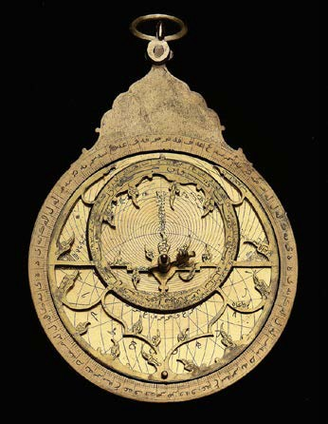
By Starlight
  - Introduce pupils to the image of the Astrolabe by Muhammed Muqim al-Yadzi and ask them what they think it might have been used for.
    - What do you think would be the equivalent device now?
    - How often do we use our devices to navigate maps?

  - In pairs or groups of three, pupils invent and design an instrument that would help them find their way if they were lost and phones did not exist.

  - Each small group prepares to share their invention with the class.

  - Volunteers report back to the group, explaining how their device would work, and pupils are encouraged to ask questions of each group and make suggestions for tweaks and improvements.

Reflection:
    - How hard was it to think of a prototype based on the knowledge you had available?
    - How much harder and important do you think it would be if you were sent back in time 500, 1,000 or even 2,000 years ago?
    - How did you enjoy inventing and imagining something from nothing? How would you improve it if you had more time?
    - What do you think of the notion that nothing is perfect first-time round?

Go Further: Combine all the thinking so far to see if, as a class, you can craft something improved and even better suited to the task.
Visit the National Maritime Museum to see the Astrolabe up close – can you spot any other details that can be incorporated into your inventions?

© National Maritime Museum, Greenwich, London

Disciplined: Crafting and Improving

Pupils work on developing their ideas and thinking big with a collaborative approach, exploring how ideas can evolve and change – they don’t need to be fixed and formed straight away.

Getting Started

Yinka Shonibare’s Nelsons Ship in a Bottle

Yinka was born in London and grew up in Nigeria. When he moved back to the UK to study art, he considered himself a citizen of the world rather than just one nation.

Yinka uses his work to show his conceptualisation of global community and citizenship. This giant ship in a bottle is one of those works. The sails of this ship are richly patterned with maritime themes in the style of Batik, carried from Indonesia to West Africa by the Dutch. The colours of Red, White and Blue that make the pattern are used to represent the Dutch and British flags, which encapsulate the culture of trade, colonialism and imperialism.

Sails have always had a strong importance within maritime and sailing history and culture. Sails flown by a ship hold a special role in identifying it. Flags have and continue to hold this purpose, to show under which nation you serve or identify yourself.

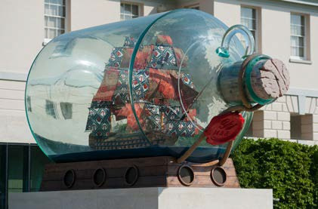
© National Maritime Museum, Greenwich, London

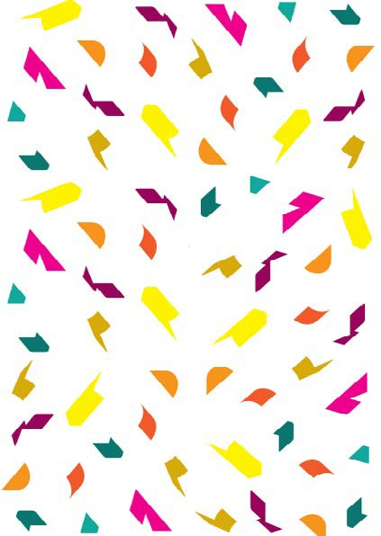
Hoist Your Colours
- Introduce pupils to Yinka Shonibare’s ‘Nelson’s Ship in a Bottle’ and ask them what they notice about the sails and patterns on the ship. Explain to them about how the colours reflect the British and Dutch flags.

- Tell pupils that flags and sails have always been used to reflect nation and identity, initially to other ships at sea and then later in more casual uses.

- Provide each pupil with a piece of A5 paper and three different colouring pencils to draw and design their own flag based on their identity or community. Encourage them to think about the colours, patterns and mark-making, and choice of symbols.

- Ask pupils to share their flags and explain their choice of symbol, colours and what meaning their flag is trying to convey.
Reflection:

- What do you think other people may think when they see your flag? How important do you think flags are in creating a national identity or symbol?
- How did it feel to create something from scratch?
- What does it make you want to find out more about?

Go Further: Research other flags of the world and think about why certain colours and images are important in these national symbols. As a class, create a flag to symbolise your class or school.
We hope you enjoy exploring the activities in these Taster Cards!

To find out more about our Teaching for Creativity work & browse more free resources, visit:
anewdirection.org.uk/ teaching-for-creativity

We’d also love to hear your thoughts! Drop us an email or get involved on social media:
#TeachingforCreativity schools@anewdirection.org.uk
@A_New_Direction @anewdirection_ldn

Resource writers: Cym Henry (Migration Museum), Tascha Von Uexkull (Foundling Museum) and Dwayne Rose (Royal Museums Greenwich)

Imaginative: Making Connections
This encourages students to think more deeply about how symbols work, and how they can conjure up feeling and understanding. It asks them to look at how a seemingly simple image can have more going on under the surface, and asks them to imagine what it could mean to others.

