Artsmark Self-Assessment framework
The Artsmark Self-Assessment framework breaks down eight criteria against the three Artsmark levels (Silver, Gold and Platinum) and Arts Council England’s seven Quality Principles. It should be used by all settings before attending the Development Day and throughout the Artsmark journey.

In conversation with colleagues and senior leaders you are asked to read through the statements below to gauge your current level of provision, your profile may scatter across the level columns. Use this Self-Assessment while planning for your Development Day as a reflective activity that will strengthen your Artsmark planning down the line. You should refer to the Self-Assessment framework throughout your Artsmark journey to aid collection of evidence of the impact Artsmark is having upon your setting and children and young people. The Self-Assessment criteria will be used to assess your application and award you an Artsmark level.

This Self-Assessment embeds Arts Council England’s seven Quality Principles, whose aim is to raise the standard of work being produced by, with and for children and young people. These should be reflected by all settings at every level.

1. Striving for excellence and innovation
2. Being authentic
3. Being exciting, inspiring and engaging
4. Ensuring a positive and inclusive experience
5. Actively involving children and young people
6. Enabling personal progression
7. Developing belonging and ownership
 | Quality Principles | Silver | Gold | Platinum
Leadership | 1  2 | The setting’s Development Plan should clearly demonstrate an ongoing commitment to quality and diversity in arts and culture education across all phases with clear milestones and measurements.
 |  | All teachers take responsibility for developing arts and culture in the setting. | A senior leader drives and develops arts and culture provision across all phases. Greater evidence of whole setting planning of arts and culture. | Settings must demonstrate over time that a named governor takes responsibility for monitoring arts and culture. A senior leader disseminates good practice across a wider range of settings.
Curriculum Design | 1  2  3  6 | The value and impact of the diverse arts and culture curriculum is firmly embedded in the setting’s curriculum offer across all phases.
 |  | Clear schemes of work and programmes of study exist to show progression of knowledge, skills and understanding for arts and culture subjects, across all phases. The arts curriculum is used to help children and young people explore or make connections in other subjects. | Curriculum design demonstrates a whole setting understanding and commitment to high-quality arts and culture provision, including experiences to perform, see live performance, and to create and evaluate artworks in a range of media. | Settings must demonstrate over time that the arts and culture curriculum offers an extended and wide variety of learning opportunities in more alternative arts and culture subjects such as digital installations, videography or public art. Older students have the opportunity to have greater input into what they learn, how they learn and how they record their learning. Settings must demonstrate that they have helped or supported other settings with curriculum design.
 | Quality Principles | Silver | Gold | Platinum
Continued Professional Development | 1  6 | The setting can provide evidence of a clear commitment to CPD in the diversity of arts and culture for all members of staff and have allocated appropriate resources to enable this to happen.
 |  | The setting can evidence regular in-house opportunities to demonstrate sharing/developing good practice in educators’ knowledge, skills and understanding of arts and culture delivery. | The setting has evidence to show that specialist artists/professionals have worked with the setting to develop educator knowledge, skills and understanding of high quality arts and culture delivery, and have collaborated on the creation of quality teaching resources. | The setting showcases over time, high quality teaching of arts and culture by offering CPD opportunities to other settings and sharing resources. Key staff support/develop and lead CPD beyond the setting, providing evidence of wider impact.
Children and Young People Engagement | 3  4  5  6  7 | All children and young people in the setting can talk enthusiastically and demonstrate their knowledge, skills, understanding and experience of high-quality and diverse arts and culture provision in their setting.
 |  | Children and young people’s art is showcased and displayed effectively and planned arts and culture events have a high take up in the setting. | Settings can demonstrate that they have involved children and young people in the planning and delivery of arts and culture experiences, such as:  • choosing visiting artists  • preparing and organising a live performance  • putting on an exhibition  • skills sharing workshops | Settings must demonstrate over time that children and young people are ambassadors for high-quality provision and learning, accompanying educators to deliver CPD opportunities in and out of own settings. Case Studies show an impact on outcomes and progression of skills in a wide range of arts and culture.
 | Quality Principles | Silver | Gold | Platinum
Range of Offer | 1  3  4  5  7 | The setting can demonstrate a diverse and universal offer of wide-ranging, high quality arts and culture experiences within and beyond normal teaching hours
 |  | Over an academic year, the setting can demonstrate a universal offer of a range of arts and culture clubs and experiences. | The setting can demonstrate and evidence children and young people have had experience of arts and culture within their community and locality such as:  • theatre trips  • museum visits  • dance events  • art gallery trips  • film clubs, moving image  • installations, public outdoor art | The setting can demonstrate over time that children and young people have had a wide range of arts and culture experiences of national significance such as:  • theatre trips  • museum visits  • dance events  • art gallery trips  • film clubs, moving image  • installations, public outdoor art
Partnerships | 1  2  3  4  5 | Settings can demonstrate that they understand the value of working with a diverse range of partners to provide and deliver high quality arts and culture education.
 |  | The setting can demonstrate that it has explored a range of partnerships to help the development of arts and culture in the setting, such as:  • contacting their local Bridge organisation  • investigating offers from other local arts and culture providers | The setting can demonstrate that it works effectively in partnership with a wide range of arts and culture providers and evidence that this is having a positive impact on outcomes for children, young people and staff.  Settings should be engaged with their local Music Education Hub. | The setting can demonstrate over time that it works in partnership on a larger scale and this may include taking a leadership role that has a positive impact on outcomes for a wider group of children, young people and staff.
 | Quality Principles | Silver | Gold | Platinum
Equality and Diversity | 1  2  7 | The setting’s Public Sector Equality Duty (PSED) or equivalent evidence should demonstrate commitment to equality of education and opportunity of arts and culture experiences in line with the Equality and Human Rights Commission’s protected characteristics.
 |  | The setting must evidence arts and cultural opportunity within their PSED evidence | The setting can demonstrate the impact of arts and culture in their PSED evidence. Whole setting understanding and commitment to equality of opportunity to arts and cultural experience. | The setting must demonstrate over time that a named governor takes responsibility for Spiritual, Moral, Social and Cultural (SMSC) learning. Good practice is shared with other settings.
Values and Ethos | 1  3  4  5  6  7 | Settings actively promote diversity and a life-long love for learning and enjoyment of arts and culture. This is reflected in the school environment, ethos and shared language used by the setting’s community to celebrate and promote their achievements in arts and culture.
 |  | The setting values each arts subject and promotes the arts and culture for the intrinsic value they have, including appropriate timetabling. Children and young people have the opportunity to develop their skills over a longer period of time. | At primary level, settings clearly plan to link the arts and culture to wider learning opportunities for children so that they can apply their arts learning in a wider context.  At secondary level settings offer a range of suitable arts qualifications so that children and young people can progress knowledge, skills and understanding of arts and culture subjects and/or signpost to other resources and providers. | Settings must demonstrate over time that they actively promote, from an early age, arts and culture as a genuine career choice and promote opportunities for experience of working alongside people from arts and culture industries.  Established and credible arts offer at KS4 which may include Arts GCSEs with good levels of take-up. Setings should be actively working towards, or have an awareness of Arts Award.
The Artsmark Awards at a glance

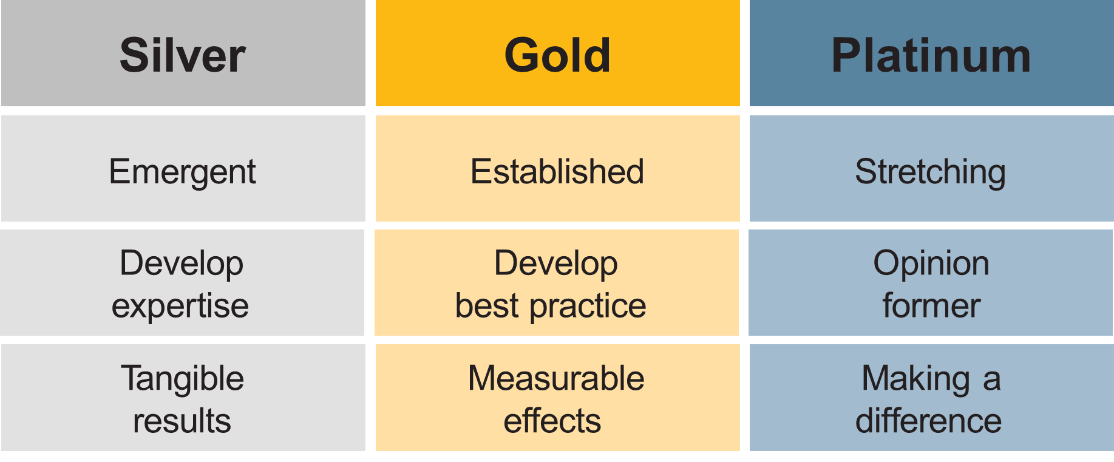
Settings will become part of the Artsmark community once they have attended a Development Day and submitted their Statement of Commitment.

