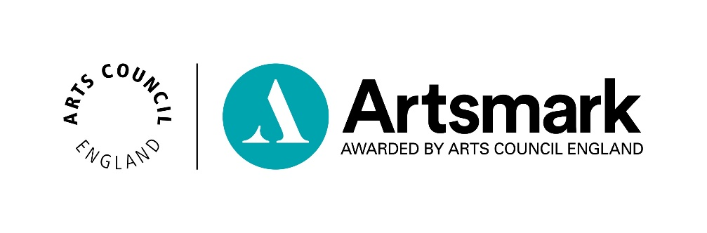
Statement of Commitment
Name of School/Education setting
DfE number (seven digits) | _ _ _/ _ _ _ _

The questions below are designed to generate a summary of your current and future commitment to developing the arts within your school. The statement will be the foundation for the Artsmark journey your school will embark upon and should create a direct link between a] arts planning and provision and b] your school's long term strategy and vision.
Please complete all six questions with no more than 500 words, include your school name and DfE number and have the document signed by your Headteacher and Chair of Governors.

Question 1 – Please explain the central importance of the arts to your school both at the level of principle (in terms of values/curriculum/developing the whole child) and pedagogically (in terms of impact on improving the quality of provision/teaching and raising standards). In your answer, please refer to both:
(i) current provision and
(ii) plans for future development of the arts
No more than 500 words
Question 2 – Following on from your answer above, please describe how and why Artsmark will contribute to your strategic school improvement plans?
No more than 500 words
Question 3 – Referring to the Self-Assessment tool, in your view, what Artsmark level best characterises your school at the moment?
No more than 500 words
Question 4 – Thinking of your future work, what will your school's action plan look like? What steps will be essential in order for your school to complete your Artsmark journey? This might include, but need not be restricted to:
- auditing current provision
- establishing whole-school curriculum planning for the arts – where the arts are used to improve teaching and learning in other curriculum areas, or where other curriculum content links to arts areas of the curriculum
- developing a CPD programme
- building partnerships with other schools and other relevant organisations
developing approaches to capturing evidence of impact and evaluating progress
No more than 500 words
Question 5 – What support will your school factor in to maximise chances of Artsmark success? This might include, but need not be restricted to:
- overall funding for the arts in the school,
- investment in CPD,
- opportunities for whole school planning,
- utilisation of external expertise – technical or otherwise
No more than 500 words
Question 6 – Artsmark will help create a network of like-minded schools. In what areas does your school already have strength in the arts and how do you know this? What areas of expertise will you share with other schools in the Artsmark family?
No more than 500 words

Signatures
Signed* by Headteacher

Full name: ________________________________Signed: _____________________________
Date: _________________________

Signed* by Chair of Governors

Full name: ________________________________Signed: _____________________________
Date: _________________________

*Signatures must be handwritten or e-signatures. We cannot accept changes of font, signatures on behalf of the Headteacher or Chair of Governors, or other signatories.

By signing this document you agree to Artsmark Award Terms and Conditions.

Please note: no hyperlinks, pictures, additional evidence documents or appendicies can be considered when levelling your submission.

Please return this form via email to artsmark@artscouncil.org.uk

Alternatively a signed copy can be posted to:
Artsmark
Arts Council England
Eastbrook
Shaftesbury Road
Cambridge
CB2 8BF

