Arts Award Data Analysis 2016-17

Arts Award is a flexible framework which offers young people the chance to get involved in arts and cultural activities, develop their social and emotional capabilities, grow as artists and arts leaders and gain a qualification. According to previous research, 95% of Advisers working with young people on Arts Award reported seeing a positive impact on their self-confidence, and 90% of Young people achieving Arts award continue to feel the impact on their artistic skills several years after completing their award. 3 out of 5 young people undertaking the award said they better understood the options for a career or further study in the arts after completing the award.

A New Direction seeks to ensure that Arts Award is consistently available to young people across London and that the organisations that work with them have clear plans for how their work can enable young people to progress and achieve through the arts. In order for this to happen, Arts Award needs to be accessible throughout London, with different sectors, centres and supporters working together strategically to maximise opportunities for all children and young people.

The following priorities and suggested actions are based on an analysis of Arts Award data from the London region between March 2016 and April 2017.
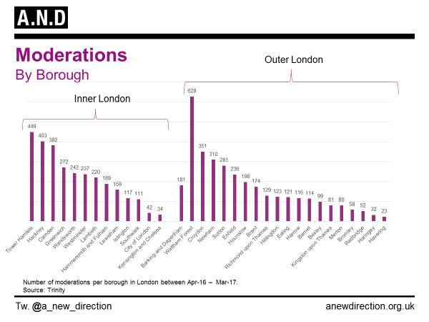
- To narrow the gap in attainment and moderation of Arts Award between inner and outer London boroughs.

Inner London boroughs are currently delivering a high proportion of Arts award, however across the board there are many neighbouring boroughs where best practice could be shared between boroughs delivering many Arts Awards and those who are delivering less.
Actions:
A New Direction advocates sharing best practice and networks beyond borough boundaries and sharing the wealth of expertise gained through successful deliver through Local Network Clusters, and previous via Local Area Networks. A New Direction can help to map and understand the cultural work and partnerships being forged in your area and neighbouring boroughs. See here for the Connected London Map

- Make a case for enhanced support and partnerships with youth and informal sectors.
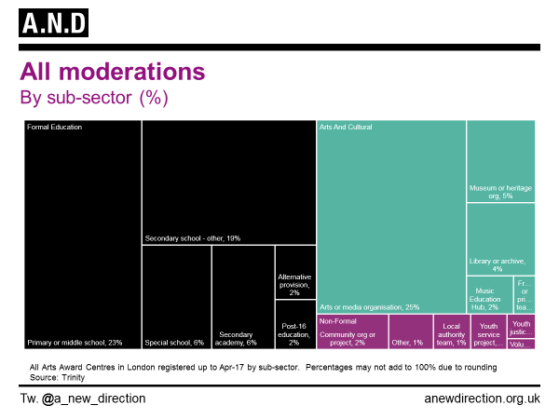
Despite Non-formal education (youth and community settings) making up 22% of Arts Award centres, this translates to 7% delivering moderations, which is one of the lowest of the above sub-sector groupings.
This may reflect a challenging climate for services.
Actions:
Exploring the role of arts organisations and corporate creative agencies in bridging the gap of Arts Award delivery and making a case for partnership from the youth and informal sector to partnership working to deliver Arts award. A New Direction will undertake Area Action research in areas of low Arts Award delivery with non-formal education settings to understand more about the challenges and opportunities that exist within the sector, and how best to support work in the area. A New Direction will also work with Arts Award Local Network Clusters to encourage best practice sharing across boroughs and non-formal settings to provide additional support, and forge new partnerships.

- To explore enhanced support and partnerships with Music Hubs, Libraries and Heritage organisations
Libraries Music Hubs and Heritage organisations are delivering 11% of Arts award in the Arts and Cultural organisations sub sector, in comparison with Arts and media organisations at 25%. Building capacity across the sector is integral to growing opportunities for young people to access Arts Award. We believed Music Hibs, Libraries and Heritage Organisations are important within this landscape and are keen to explore ways in which we can support them to develop their Arts Award offer.

Actions:
- To utilise the Museums Learning Group at A New Direction to learn and implement best practice.
- To understand the crucial role that Music Hubs, Museums and Libraries have in Cultural Education Partnerships strategy and delivery outputs and works that support strong partnerships
- To work within the Local Network Clusters to support activity with Music Hubs, Libraries and Heritage organisations, across boroughs.

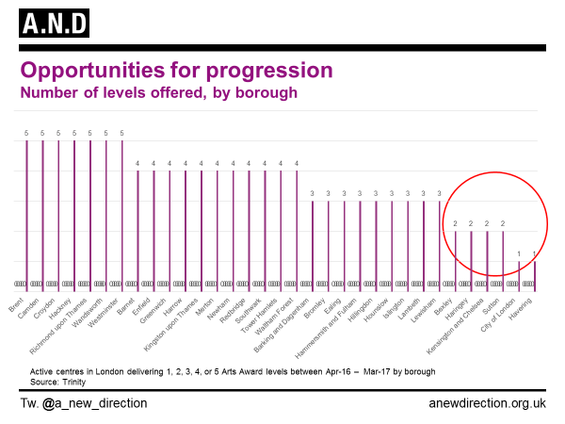
- To explore and embed broader progression routes for Arts Award across boroughs and progression and attainment of higher levels
Opportunities for progression at all five levels are offered by a quarter of all London boroughs.
A New Direction is committed to ensuring young people have access to progression across levels of Arts award.

Actions:
- To pilot Action Research in Gold Arts Award delivery and utilise the findings to ensure more boroughs can access a shared Gold offer.
- To undertake Area Action Research in boroughs with low progression and moderation levels to support sustainable progression to higher levels of Arts Award where there are none, or few currently available.
- To work with Local Network Clusters to explore cross borough and intra borough partnership working to consider providing progression routes as part of a ‘shared offer,
- To support organisations and partners with information and guidance to access longer programmes in funding for working with young people in Arts Award.

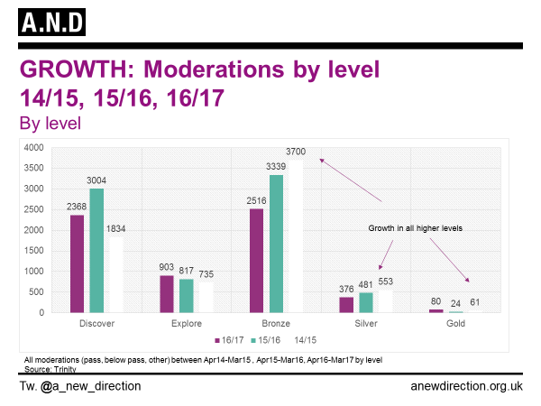
.

- To encourage more NPOs to support and deliver Arts Award
Many of the NPOs that are supporters are also centres, suggesting that these highly active organisations account for much of the Arts Award activity in the Arts sector.
Actions:
- To consider possibilities of working in partnership with other NPOs’ to share best practice
- Understanding NPO reasons and benefits of supporting and delivering Arts award and sharing this evidence across the sector.

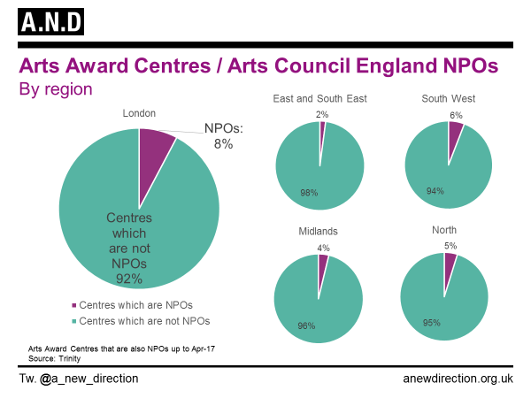

Hollingworth, S; Paraskevopoulou, A; Robinson, Y; Chaligianni, E; Mansaray. A (2016) Arts Award Impact Study 2012-2016: A report for Trinity College London. London: London South Bank University.

