Arts Award 2016-17

Local Area Development
Arts Award is a creative, valuable and accessible way to inspire young people to grow their arts and leadership talents. A New Direction are committed to ensuring more children and young people in London can celebrate their achievements and progression through Arts Award.
For the last two years, A New Direction have analysed Arts Award data in order to identify areas of low Arts Award engagement in London. In 2015-16, they set up a Local Area Development programme to support organisations and partnerships to scale up their Arts Award offer and connect with more children and young people. This year has seen a continuation of this programme so that new areas of London can contribute to this continual sharing of learning.
As with the 2015-16 Local Area Development, the programme seeks to explore the question:

“What conditions and partnerships need to be in place to make Arts Award work in areas of low engagement?”

An Action Research approach continues to be used in order to support learning and develop a deeper understanding of how schools, local authorities, cultural organisations, freelancers and informal settings can all support children and young people to achieve through Arts Award.
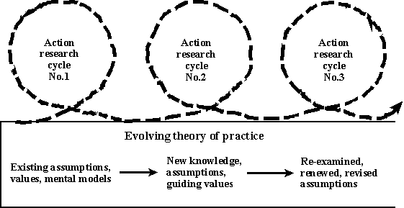
The exploration thus far has been structured to three meetings. An introductory meeting, an action research set up meeting, and a midpoint exploration of key challenges, the barriers involved and how they can be overcome. Each organisation has also had regular meetings with an evaluator to re-examine, revise assumptions, and make continual changes. These conversations have formulated this report. The programmes will continue into late Spring 2017, So this report aims to capture learning of programmes until at least the final stages of delivery. Due to the differing programme timelines, certain programmes have amassed more action research learning and observations to date. This is presented in individual case studies that capture a different point in time for each programme.
Regarding the action research approach, partners reflected that hearing about other organisations’ challenges and how they overcame them was useful. They liked sharing insights, resources and management strategies and appreciated the structured network meetings. For the future, they suggested running twilight meetings where additional teachers and partners could be invited. Approaches for continued sustainability and further development are also being discussed.
Organisation | Borough | Partners | Predicted Output
Chingford Academies Trust | Chingford | Fullwood Primary, Redbridge Primary, Glade Primary, Roding Primary, Manford Primary, Cleveland Road Primary, Mossford Primary, Leverton Primary and Cranbrook Primary | 120 Discover
Crafts Council | Ealing and Brent | Northholt High School, The Ellen Wilkinson School for Girls, Dormers Wells High School extended to include three Brent schools Queens Park Community School, Capital City Academy and Woodfield School. | 70 Bronze, Silver
Into Film | Islington | Vittoria Primary, William Tyndale, Laycock school | 45 Discover  47 Explore
Lewisham Education Arts Network | Lewisham | Trinity Laban Conservatoire of Music and Dance  Lewisham Music Service & Hub  St Augustine’s Primary School  Prendergast Ladywell Primary  Beecroft Primary  Edmund Waller Primary | 75 Discover, Explore
Orleans House | Richmond | Norwood Green Primary, Meadlands Primary, Crane Park, Primary | 60 Discover, Explore
Haringey Play Association ( Latterly New River Studios) | Haringey | London Borough of Haringey (Youth Service and Regeneration), Homes for Haringey, New River Studios, The Sandlings Residents Association, Edgecot Grove Residents Association, Jellot Promotions Youth Club, Campsbourne youth club. | 45-50 Bronze, Silver

Common Themes
The themes that have been reported can be loosely grouped into three categories:
- Process:
- Introducing the programme- Programmes reported being more successful when they were introduced to stakeholders and partners early on in the process. Involving partners in planning and timetabling cascaded made programmes more efficient and simple to run.
- Embedding into pre-existing processes – Once a programme is introduced with ample planning time, take into account what other processes are in place and how they can be integrated. For example, using resources or activities that are already happening to gather portfolio evidence, rather than reinventing an entirely new booklet.
- Reflect your borough – Programmes that made their offer reflective of the local borough and opportunities reported added excitement and commitment from partners and key stakeholders.
- Getting specific training – Where programmes were able to cater their Arts Award training specifically to staff, they were able to integrate project planning into the day. This enabled them to map the programmes out as they were being trained. They reported feeling confident in using the resources supplied and in practically applying their training after this.

- Conditions:
- Ensuring that all partners understand Arts Award as a concept - In order for a project to thrive, these programmes felt that all partners needed an in depth understanding of Arts Award. Sharing past portfolios, having young people speak about their experiences, and consulting with stakeholders about which parts of Arts Award appealed most all worked to ensure that partners understood the principles of Arts Award.
- Using staff in the right way – With capacity always an issue, it was important that staff at each level were consulted about their involvement. Cross departmental communication was encouraged to prevent duplication. Programmes that were able to assign staff to elements of the project that suited their skill set reported greater commitment and enthusiasm.
- A bespoke approach – When working with multiple partners, often across locations and Arts Award levels, flexibility was necessary. The organisations continually adapted their timetables and budgets, added extra training dates, consulted on portfolios and supported partners in a way that suited them. This fluid approach was reflective of an Action Research approach and enabled programmes to work around the partners’ needs.
- Enabling progression – When developing the process, consider how young people will progress across levels or what opportunities they may access next. This is particularly important when looking at the infrastructure and partnership working of a borough.

- Partnership:
- Meeting staff across levels – Partnerships were formed at many different levels. Where partners were able to meet both senior management and those who were delivering, they had greater communication. This enabled more flexible timetabling and creative delivery.
- Finding the right person – Most programmes found that someone’s job title does not necessarily make them the right person to lead on an Arts Award project. Particularly in schools, organisations found that a more general call out for Arts Award interest rather than just working with an Arts coordinator unveiled hidden talents at delivering the Award as well as the potential for cross-curricular work.
- Finding the key selling point for partners – for some this was the qualification, whilst for others it was Arts Award’s reflective learning and creativity. Determining how to best represent the award and get stakeholders on board was important particularly where the arts are not necessarily a strategic focus.

Chingford Academies Trust
Arts Award at Chingford Academies Trust (Chingford and Rushcroft Foundation Schools) has a nationally recognised profile. They have been delivering the award since 2008 and decided to make an ambitious move this year; delivering a bespoke “Redbridge Focus, London Curriculum, Discover Arts Award Programme” in nine Redbridge schools. They did not anticipate working with so many schools at first, but after an extremely positive reception they revised their project plan.
“All the schools in our network are very keen” – Jas Leverton, Head teacher, Cranbrook Primary School
“All the schools offered the opportunity to take part have jumped at the chance” Yolanda Guns, Arts coordinator Chingford Academies Trust
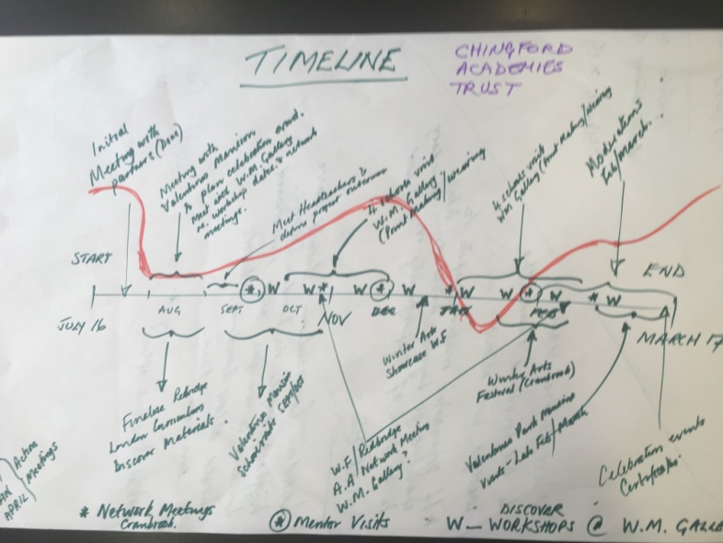
The programme built on a successful pilot from Waltham Forest last year. Chingford Academies sought to engage new Redbridge primary schools in delivering this pilot to groups of Pupil Premium students with a focus on local arts and culture. It involved a visual art workshop at William Morris Gallery; where pupils received workshops in craft and creative writing. The project involved a multitude of art forms, so that the young people would have a choice in the method of their participation. The Arts Award delivery team included teenage Arts Award Ambassadors, who shared their good practice and provided positive role models for the pupils involved. They delivered two or three workshops at each partner school. The timing of delivery was paired with the Redbridge Winter Arts Festival, so the young people would have something tangible to work towards.
“I wanted to let you know how much the children enjoyed their visit to the William Morris Gallery (as part of their Arts Award project). They liked sketching the designs and had lots of fun experimenting with the printing.” teacher feedback
In order to bring partners together, Chingford Academies first met with the head of their “host” school in Redbridge and then brought all nine Head Teachers together for an introductory meeting. The Project Coordinator created a bespoke Arts Award booklet for this occasion, so they would have something concrete to look at. She found that this really helped the partners commit, as they knew what to expect.
The next step was to involve the young people’s parents. The coordinator felt that if they could win families over, it would be easier to advocate with the schools for long term Arts Award engagement. Initial launch events saw each parent invited in to speak to the coordinator and see examples of previous work.
“Liaising with parents at the start of a programme can make it a family-learning experience. It also helps to enlighten some families about the arts and cultural opportunities available for residents in Redbridge and neighbouring boroughs” Yolanda Guns, Arts coordinator Chingford Academies Trust
Challenges:
Awareness: The schools were not aware of Arts Award at first. It was therefore important that it was introduced holistically and across art forms. A pre-designed booklet, visual aids, and young people speaking of their own experience were vital. Using key words such as “careers in the arts” was also helpful. Chingford Academies Trust are establishing time for additional Arts Award sessions to be led by school staff, so that it becomes more widely understood and embedded.
Logistics: The higher participation numbers were logistically challenging. The Project Coordinator spent extra time managing trip visits and balancing the budget. She joined school groups together for gallery visits in order to make this work, which the schools reported that they really enjoyed.
Successes:
Set up: It was particularly noticeable how present and engaged the Head Teachers were. Having some pre-existing relationships helped, but even those without previous knowledge of the work were enthusiastic because this programme offered a new and different approach. The local context made it about more than just the arts as they felt their local area would benefit too. They particularly liked seeing the Arts Award booklets at the start of the programme because they were tangible and clearly packaged.
Fluid approach: The Arts Award booklet designed specifically for this programme allowed room for young people’s creativity. The sessions were designed to encourage debate, opinion and conversation. This meant that even though all the schools were using the same template, the young people had real ownership of their time management and the content of their booklets. They were able to shape the programme around their own interests, and a natural focus around careers in arts was able to be explored.
“As Head Teacher it has been wonderful to see the children and their parents beam with joy and talk with enthusiasm and confidence about their participation in the project. This is especially true in relation to their self-esteem”. Jas Leverton, Head teacher Cranbrook Primary School
The right contacts and partnerships: Making contact with a school head who is influential with other heads is pivotal. It meant that schools were recruited quickly and successfully. Targeting a network of schools who all take part in the Winter Arts Festival made this easier as they were already working together towards a common goal. This helped the programme to be unrolled quickly and managed easily. Offering opportunities to schools and not saying they ‘should’ do things works, as does engaging teachers via private views and wine for meetings on Thurs and Fridays.
The involvement of parents as “partners” during this project. Has worked well. They were offered a parent’s meeting at all schools before the project commenced. These were largely well attended and parents were keen to understand about what their child would be studying. They were also interested in ways in which they could assist them at home. Examples of success included a pupil returning to William Morris Gallery after his original visit/workshop, with his father, so that he could show him where he had been and another bringing in some painted china she had produced at home after her mother had bought the materials for her to undertake the work.
Replicable: The focus on Pupil Premium students could help make the programme both replicable and sustainable for the future, as well as a set of resources and booklets, assessment report form and pro- formas. Inviting schools that haven’t been involved to the final celebration, and making it high profile works. Networks are being sustained in Redbridge, however the borough will be divided into geographical regions without lead schools so MAT’s learn about other schools and what they are doing. This could pose an opportunity to ensure quality connected arts provision in the schools.
Final reflections: It is very relevant that the pupils grasp of; and retention of knowledge about inspirational arts practitioners was significantly enhanced by the fact that they were learning about local arts heroes. It excited them that they could relate these people to places they knew as part of their everyday lives. They also discovered places of heritage and culture which they could visit easily with their families.
Project leads learned how very meaningful an experience this project was for this group of Pupil Premium students and were surprised at their low base of knowledge at the project outset and lack of awareness of arts and culture in general and their local opportunities. It was encouraging that the pupils were keen to develop their skills and understanding in the various art forms covered, as the project progressed. They also showed enormous progress in terms of their self-confidence and self-esteem when interacting with others during workshop sessions with us and when sharing their skills.
Year 5 pupils from Fullwood Primary School showing the “William Morris” inspired Get Well cards they made for one of their classmates who is in hospital.

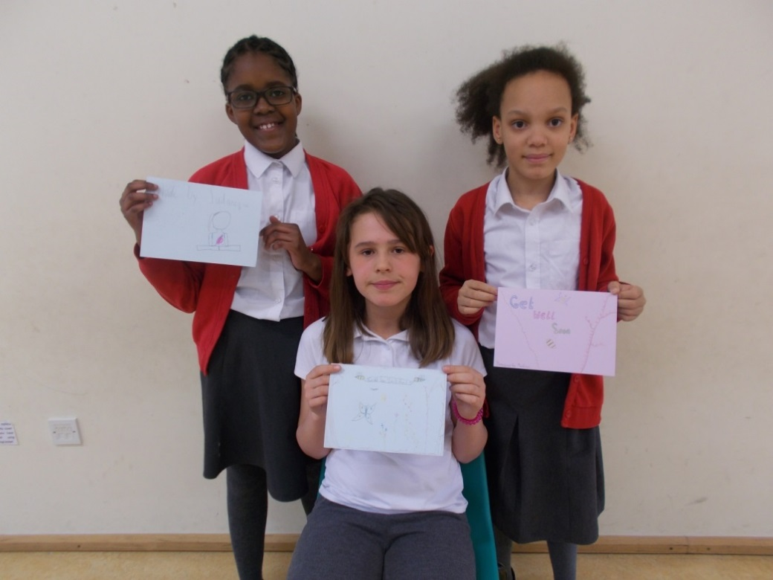

Wall display showing the work the pupils produced during their print-making workshop at William Morris Gallery for their Part A of their Redbridge “London Curriculum” inspired Discover Arts Award.
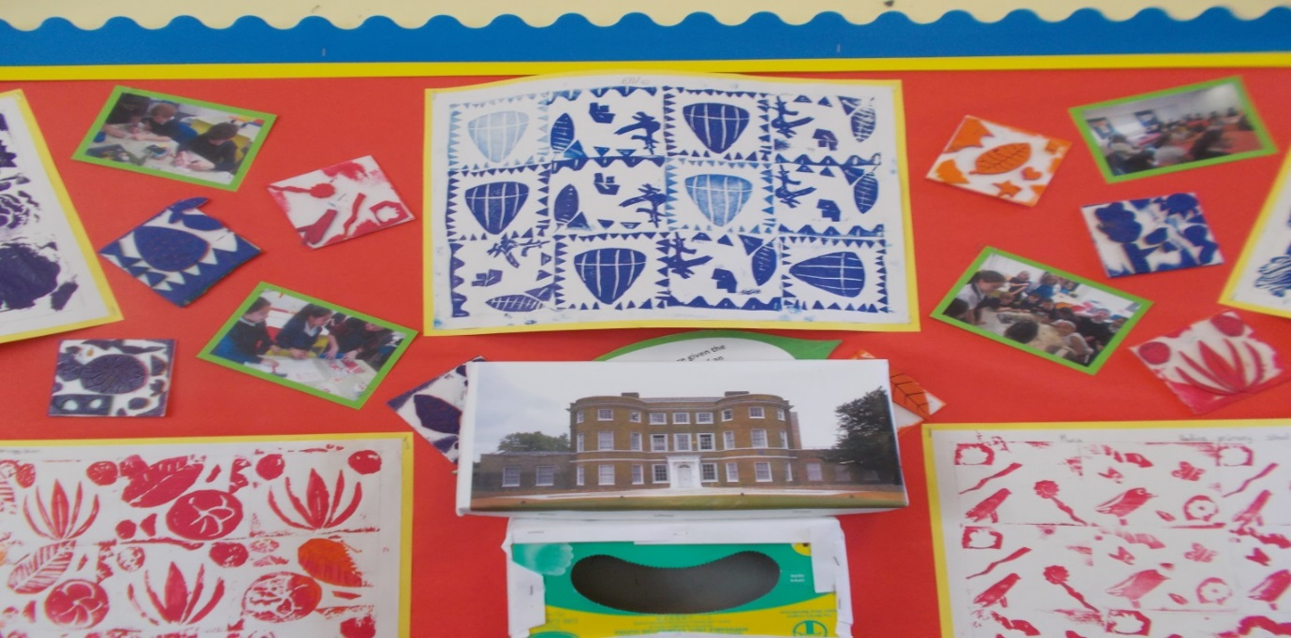

Crafts Council
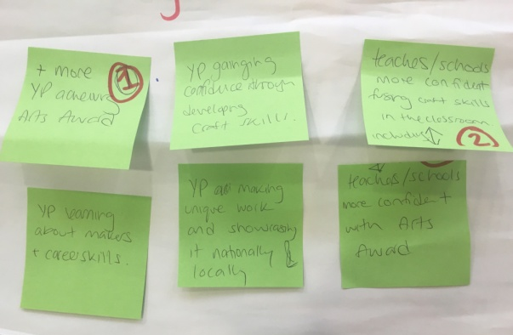
The Crafts Council worked in Ealing, using Arts Award as a tool for linking art, design and technology across the curriculum. They explored how they could support more local centres to deliver Arts Award by embedding it into the curriculum. This offer was developed alongside Make Your Future, a three-year schools programme launched in 2016. Make Your Future is a cross-curricular programme that empowers teachers and pupils to use craft as a meeting point between Art and Design.
The Crafts Council did not have pre-existing relationships in Ealing, so first they had to find gatekeepers and contacts to help them with the school recruitment process. They also hired an Evaluator to work on the wider programme and embedded Arts Award into this. They sent a baseline questionnaire to local schools, asking about their current knowledge of Arts Award, their interest in it, their current level of delivery and if they have any trained advisors in order to inform their next steps. The results of this questionnaire helped them shape their offer.
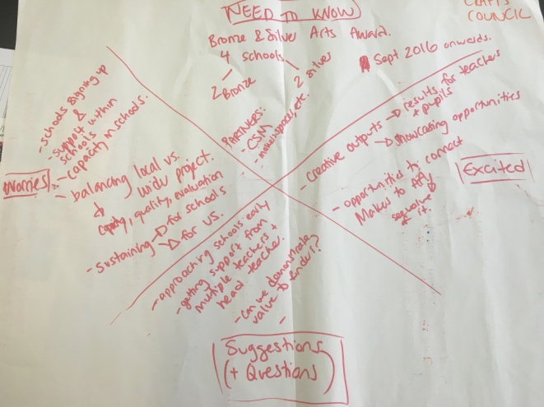
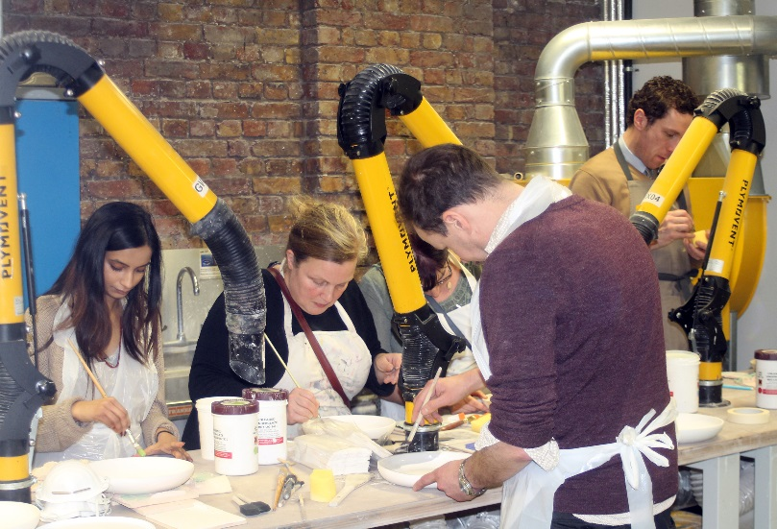
After recruiting five schools, two dropped out due to illness, staff shortages and Heads moving on. Communication between schools and staff continued to be a problem, but regular phone calls and meetings helped them progress in planning. The Project was extended in March 2017 to include three Brent schools Queens Park Community School, Capital City Academy and Woodfield School. As the programme progressed, the Crafts Council met with more local arts organisations such as West London Arts Scene and OPEN Ealing. West London Arts Scene will now be working with older groups through the Make Your Future schools recruited by the Crafts Council. The young people’s work will be displayed on borough wide library tours and young people undertaking their Silver Arts Award will help set up and run open days. A Central St Martin’s CPD session for teachers
From January to March, the Crafts Council ran twilight CPD sessions with teachers and are offering pre- moderation visits to each school. These will include conversations about how Arts Award can be embedded in the future. They are also developing a mapping resource for teachers, which will be shared at the first CPD event.

The Ceramics Artists will deliver intensive or weekly sessions in the schools and a freelance Coordinator will offer a day and a half per school to support delivery and portfolio creation. The Crafts Council are designing a blank sketch book that the young people can complete as their Arts Award portfolio. This high quality logbook brings a professional feel to the programme, thus inspiring the young people to commit. It also allows room for flexibility, as the young people can shape the contents and structure they choose.
This programme is at an earlier stage in its delivery and this is reflected in the below.
Challenges:
School Recruitment: Working in an entirely new borough made this challenging. The Crafts Council had to take a broader strategic approach to the borough and read strategy documents first. They then set up new contact with gatekeepers to help them reach schools. In addition; Make your Future teacher CPD has over-ran and schools dropped out in Ealing. Schools engagement and retention was an ongoing difficulty. However, Brent has been keen to work with Crafts Council. Another issue is that teachers find it hard to find time to attend AA training. Cross curricular work for Arts teachers is frightening as they want to show that they have value on their own without collaborating.
Finding Gatekeepers: Finding the right local contacts took longer than anticipated. Speaking to Ealing Council’s extended services adviser/school effectiveness adviser was particularly helpful. The Crafts Council also researched current and past Arts Award offers in Ealing by a range of organisations, and considered how to build on these existing frameworks and relationships. Using the Make Your Future model and extending the offer to Brent schools was effective. However, lack of engagement in schools in Ealing is worth exploring.
“Recruitment in schools has been successful when there has been one individual taking charge pushing others along….so that is key, finding the individual who can make things happen.” Crafts Council Project Manager
Successes:
School Recruitment: Once the Crafts council were working with Ealing Council’s Extended Services Adviser/School Effectiveness Adviser, who put the offer for schools on the Ealing Grid for Learning, they had a good number of enquiries.
“Teachers have been excited by the CPD offer. They have been really keen to take part, but often have to talk the senior management into doing it. There are a lot of very passionate teachers wanting to put in extra time and energy for their students, despite having busy and difficult work patterns.” Crafts Council Project Manager
Work from Year 10 Student Queen’s Park Community School
Developing partnerships: Meeting with Ealing based Arts organisations gave The Crafts Council a clearer picture of what was already being delivered in Ealing. They are looking to broker longer term relationships and work with these local centres to make sustainable offers that are embedded across the borough. Teachers have met makers that they would be working with and an Arts Award Associate adviser was there which they enjoyed and valued.
Working Flexibly: The programme was shaped through feedback from local arts organisations and schools. The bespoke approach was vital in helping teachers fit it into their schedules.
“We are working very flexibly with schools and we are finding it’s really important to listen to them on a 1:1 basis when planning each aspect of the project as needs are diverse. Secondary schoolteachers are faced with many challenges that could prevent them from taking part. In London there seems to be a high turnover of teaching staff and illness, including long term sick leave. Their time is very limited to the extent that they don’t have time to even read the emails/documents we are presenting. Phone calls have been very helpful to go over the details, rather than them reading through lots of information. The personal touch has been valuable in all regions and a friendly ear who knows the challenges they face, showing a willingness to make it work for them.”
Crafts Council Project Manager
Final Reflections:
Earlier introduction to Arts Award
Due to difficulty in recruiting schools the Crafts Council altered the timeline for the Make Your Future project, and as a result did not meet the teachers until early this year. Ideally it would have been good to deliver the Arts Award introductory CPD session much earlier in the school year, so that the teachers would have had a more time to book in training, understand the award and then have more time to prepare to deliver.
Recruiting additional schools/ training additional teachers
Was a secondary solution to problems of building relationships with teachers and schools and account for high turnover of staff

Change Takes Time: Building relationships
In a difficult climate for arts education and teaching staff, the project was a good opportunity to engage with staff in an open way. Nascent teacher partnerships developed by training and working at Central Saint Martins over six weeks. There is a need to explore how to mobilise and solidify these relationships to deliver Arts Award. Teachers have developed contacts with Practitioners and advisers such as Tiger Monkey and delivery Artists. West London Arts Scene for example have been touring around Libraries in Ealing. Students on the programme can then peer educate families.

Haringey Play Association
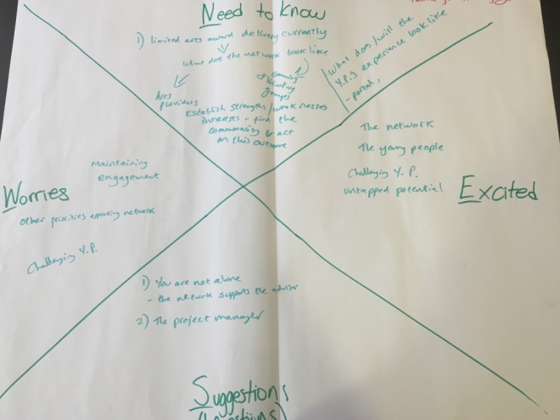
Haringey Play Association (HPA) is exploring the barriers that stop young people from accessing and engaging with local creative opportunities. They wanted to test how these barriers can be overcome, what approaches work in reaching and engaging young people and how this works across different areas in Haringey.
They developed a network of local organisations from different sectors; including the Youth Service and Regeneration teams of London Borough of Haringey, Homes for Haringey, The Sandlings Residents Association, Edgecot Grove Residents Association, Jellot Promotions Youth Club. New River Studios were the lead arts partners, offering their space for workshops and a final film festival.
The programme was developed for four different estates in the borough, each with diverse groups of young people working towards their Bronze and Silver Arts Awards. Due to how large the borough is, they are interested in mapping out local arts opportunities and identifying a bespoke approach for each strand. On the Northumberland Park estate, for instance, they ran a one week intensive film making programme, followed by time for portfolio and film completion. On the Campsbourne Estate, on the other hand, there is no venue to run workshops from. The London Borough of Haringey Youth Service therefore commissioned them to do outreach on estates and provided the team with a van which they can use to transport young people to and from New River Studios. HPA are running this strand as an introduction to the arts by running tasters on different art forms.
The programme start was pushed back due to delayed match funding, DBS issues and staffing changes. The programme was originally led by Homes for Haringey, but ownership was transferred to HPA after staffing changes. They commissioned the Project Manager who had previously been running it, but these changes took time. It is at an earlier stage in its delivery and this is reflected in the below. New River Studios has now become lead delivery partner in the programme and moderation for Arts Awards is expected to be completed by late June/ early July.
Overcoming Challenges
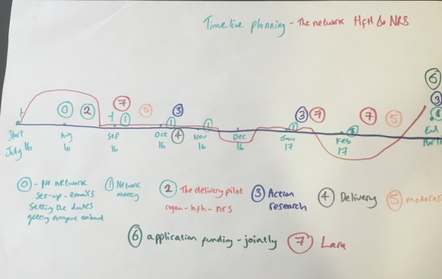
Changeable borough infrastructure: Staff member changes, insecure funding, youth clubs closing down and a lack of permanent spaces were definite challenges to getting this programme off the ground. Securing a minivan and a staff member from the local council helped address some of this.

Timeline: Getting a new timeline in place after delayed payments required the partners to regroup. They met again and invited the council to a network meeting. They have also paired the programme with other projects. For example, working alongside a local girl’s programme with Children in Need funding to integrate Arts Award made planning simpler.

Young people in North Tottenham working on a documentary film.
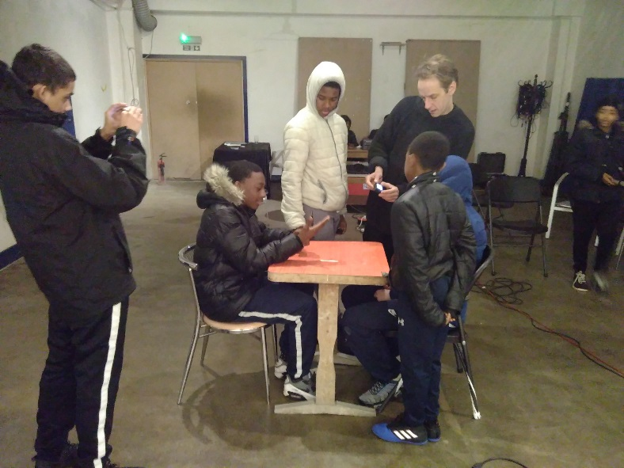
Successes
Building the right partnerships: Extra set up time meant that HPA could build a full partnership with the Youth service. They approached them with funding in place, a clear plan and very specific requests. For Campsbourne Estate, for instance, this was for one member of staff and transport. HPA were able to present what Arts Award is and gave statistics from AND research to help make their case. The voluntary groups and resident associations they built contact with have also been offering invaluable support in reaching young people.
“Having been to the arts building once, the young people now really want to go back. We had to cajole them into it at first. Getting them out of their comfort zone- they were dragging their feet. But once they were there, they were up on stage participating in a show and loving it”
Jason Bradley, Project Coordinator

Scheduling: The extended timeline involved building a schedule for all four projects to take place on different days and access New River Studios at appropriate times. This will involve them purposefully crossing paths with Artists using the rehearsal rooms and getting free meals from an onsite kitchen.

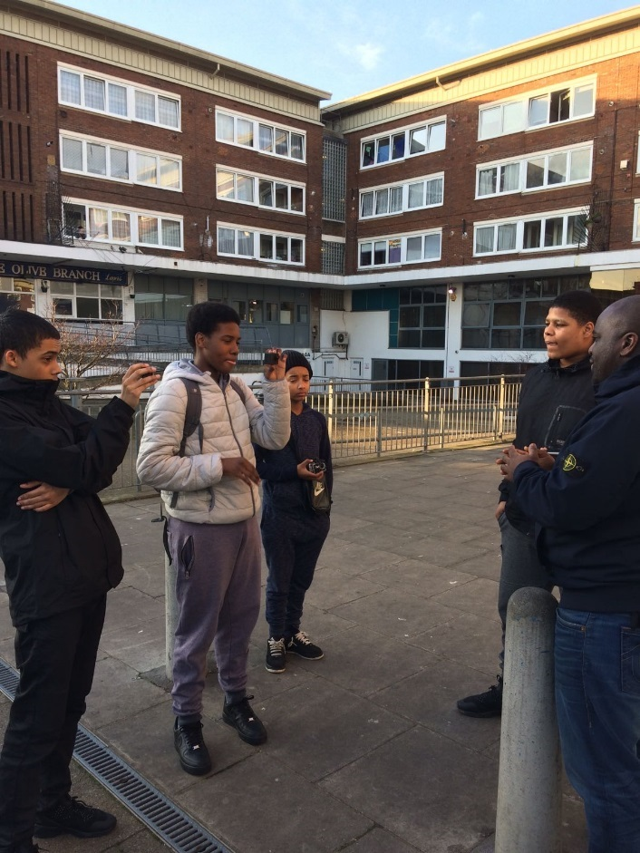
Young people in North Tottenham filming
Staffing: As the programme is split across locations, HPA had to find the right members of staff to lead on different strands. They had to be committed, already engaged in the locality and running programmes with young people in the area. The lead Project Manager, for example, was already volunteering in one of the commissioned Youth Centres.

Final Reflections:

Policy and funding landscapes
Arts Award take up in a youth service context in Haringey is severely affected by local authority cuts to youth services.
Low take up in Haringey is because of the local authority cuts. There is funding for children but next to none for young people in the borough.

The role of Arts And cultural organisations in a changing climate:
Since the beginning of the programme the lead organisation, Homes for Haringey / Haringey Play no longer works with youth, and New River studios has become the lead organisation.
In Tottenham youth services and projects are increasingly being funded by private or corporate (Mainly music focussed) sources, and delivered by arts and cultural organisations such as New River Studios. This poses interesting questions as to the role of arts and cultural organisations as having the capacity to deliver Arts Award in areas of low engagement, rather than traditional youth service provision, and area based partners for example social landlords. Young people have engaged in a wide range of arts forms, which may not have been possible if the programme had been delivered by a social landlord as initially intended.

Sustainability and staffing:
This project has relied on the commitment of two individual leads rather than an organisation, who have used their knowledge and links to Local Authority and youth workers on estates to gain one member of staff and a mini bus to deliver the programme, if the project were to be repeated or be sustainable perhaps it would need a focus on a replicable resource, as it would be difficult to replicate otherwise. Informal youth workers (people living on estates) cannot be valued enough as they play a significant role in young people’s lives and are effective role models for engagement. Arts Award at Bronze and Silver levels often needs more than one member of staff per 10 young people and this poses a challenge in the current youth provision climate in Haringey. Y

Area, attainment and engagement
It is important to note that Hornsey and South Tottenham are completely different and that some areas in boroughs already have effective arts provision that is not focussed. There is a big difference in these areas between people’s backgrounds and behaviour. The group dynamic affects young people’s attainment and young people excluded from school or living on their own make up the whole of some groups which affects their ability to concentrate. Arts Award, though flexible is still directly affected by young people’s educational background. Transport and travel have been essential to ensuring young people can access services.

Into Film
Into Film worked with three Islington Primary schools to deliver 80 Discover and 80 Explore Arts Awards. They sought to develop a light-touch but informative model and resources that would enable their network of Schools and Youth Groups to deliver the Discover and Explore levels of Arts Award. In order to do this, they brought in an external Coordinator with an expertise in Arts Award, who facilitated resource development and developed a clear project timeline and plan.
The aim was to develop customisable log books that could be housed on the Into Film website for teachers download and use in their own future programmes. Four very different Film Clubs were initially recruited, but one dropped out due personal circumstances. The diversity of the Film Clubs helped contribute to the creation of some unique resources. For instance, one school delivered Discover with Reception, another worked with mixed age young people with speech, language and communication difficulties and the third delivered Arts Award through a lunch time French club.
Into Film offered an Arts Award training and planning day with teachers from selected Film Clubs, where they also introduced them to a variety of filmmaking activities. All the teachers involved had either never heard of Arts Award before or had read a bit about it, but none had previously seen or taken part in delivery.
The plan was for the schools to deliver Discover in a Day before the 2016 winter break and Explore in the New Year. The approach became more bespoke in order to suit the schools as the project went on, however, as each was using different models, age groups, and timelines. Into film supplied one artist’s visit for the Explore level and the teachers all had half a day non-contact time included in their contracts.
The Project Coordinator created resources that can be adapted to any book/film, aimed at teachers and film club leaders, or other practitioners using film to work with young people. The workbooks were created for children aged 7-11, with links to primary and secondary age resources on the Into Film website. For example, a Knuffle Bunny PowerPoint booklet template was created as a prompt for Arts Award Discover. Additional resources such as “Discover in a Day - Arts Log”, “Film Industry job cards”, and “Film Writing Diaries” were also created and will be widely available on the website.
To complete this programme, Into Film are planning a celebration event, with the potential of sharing portfolios between schools and aligning this with a moderation day. School heads will be invited to see the outcomes in the hope that they will support more of these kinds of programmes in the future.
Challenges:
Timetabling: Discover in a day was difficult to organize in school via film clubs, as teachers do the clubs as an extra-curricular activity with a mix of children from different classes. They opted to deliver the Discover level in 3 – 4 hour long sessions instead. As such, the planned face to face supported delivery by the coordinator was not appropriate, so support was being given via phone and email.
Different staff approaches and needs - The Project Coordinator adapted the content of the programme to suit each school’s activity. Some teachers needed more support, so The Project Coordinator offered more contact time where necessary. All teachers needed help with administrative aspects, such as registering young people. The coordinator also worked to manage children and teacher expectations about what could be achieved in the allocated time. This high level of support suggests that a Coordinator may be needed to manage such programmes in the future.
Sustainability: Although knowledge and resources are being developed, it is unlikely that schools will pay for certificates next year. They like Arts Award and will probably continue to deliver, but are considering printing their own in-house certificates. Some consideration of how more light -touch support can be offered next year needs to be given as this year has been resource -heavy. In order to share learning and get new schools on board, Into Film will invite local school heads to see young people’s art. They will also consider how the resources developed are shared on the Into Film Website and explore how they can be used. School trips for schools were met with resistance too due to concerns about terrorist threat and risk assessments for public transport.
Successes:
Arts Award Training: teachers were enthusiastic about delivering Arts Award through film following their Arts Award training combined with practical film CPD. This mixture extended the half day training to a full day, to include bespoke information, planning time and a chance for the teachers to try different filmmaking activities themselves. The delivery team are considering if in-house training across the school would be possible with future primary schools.
“I really enjoyed the animation presentation and getting the opportunity to film our own films and animated video “Teacher feedback, Into Film Arts Award Training
“I really liked all the materials to help with Arts Award planning “Teacher feedback, Into Film Arts Award Training
“I want to do this at other schools where I work. I love it. The children love it. They want to keep doing more and more - we can’t stop! teacher feedback
One of the teachers was initially concerned about delivery and so created a fantastic booklet of her own for Discover:
“I always thought I would not be at the same level as other primary schoolteachers given that I am an Modern Foreign Language Specialist, but my general education has been of great help ...
I can only teach/share what I know, but I’m always willing to learn more from experts like the three of you.
I am excited to make a start now I feel more confident.” teacher feedback

High quality, diverse resources and learning: The Project Coordinator is designing a matching tool so that existing Into Film resources can be mapped into Arts Award projects. She has also written case studies to be added to Into Films website alongside the new resources. Into Film are working with AND to launch the resources at the end of the programme.
Activity Diaries have been great-teachers have encouraged children’s reflections by writing comments in different colours and using emoticons. The Arts Award way of documenting might be sustainable via writing diaries; however, costs and time are still difficulties. An Animator visited three schools in one day and produced great photos.
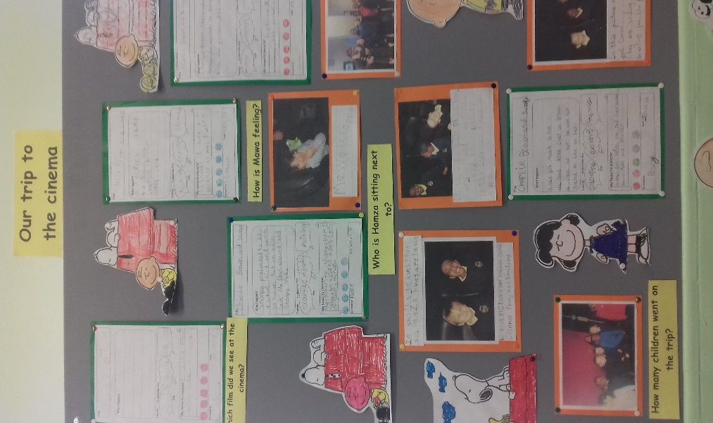
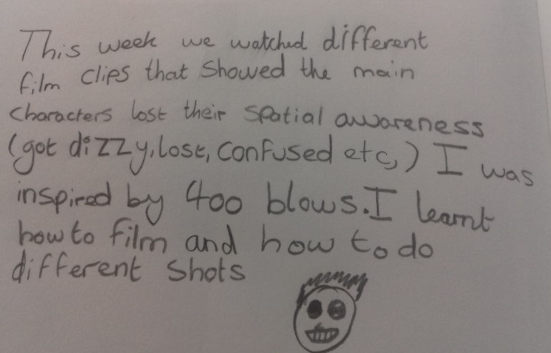
Work from a pupil at Vittoria Work from Pupils at Laycock Primary
"I started negatively. I didn't think I could manage it. I'm not an artist - is it for me? ...I fell in love with the project. I loved the freedom to be able to choose while having the guidance to keep us 'square'...it is something I've never been able to embrace, but if one of the students becomes an artist one day that will be fantastic. ...some of them don't move from where they are - they go from home to school and don't do anything. This project has given us the chance to do many creative activities and find out about artists." (teacher feedback)

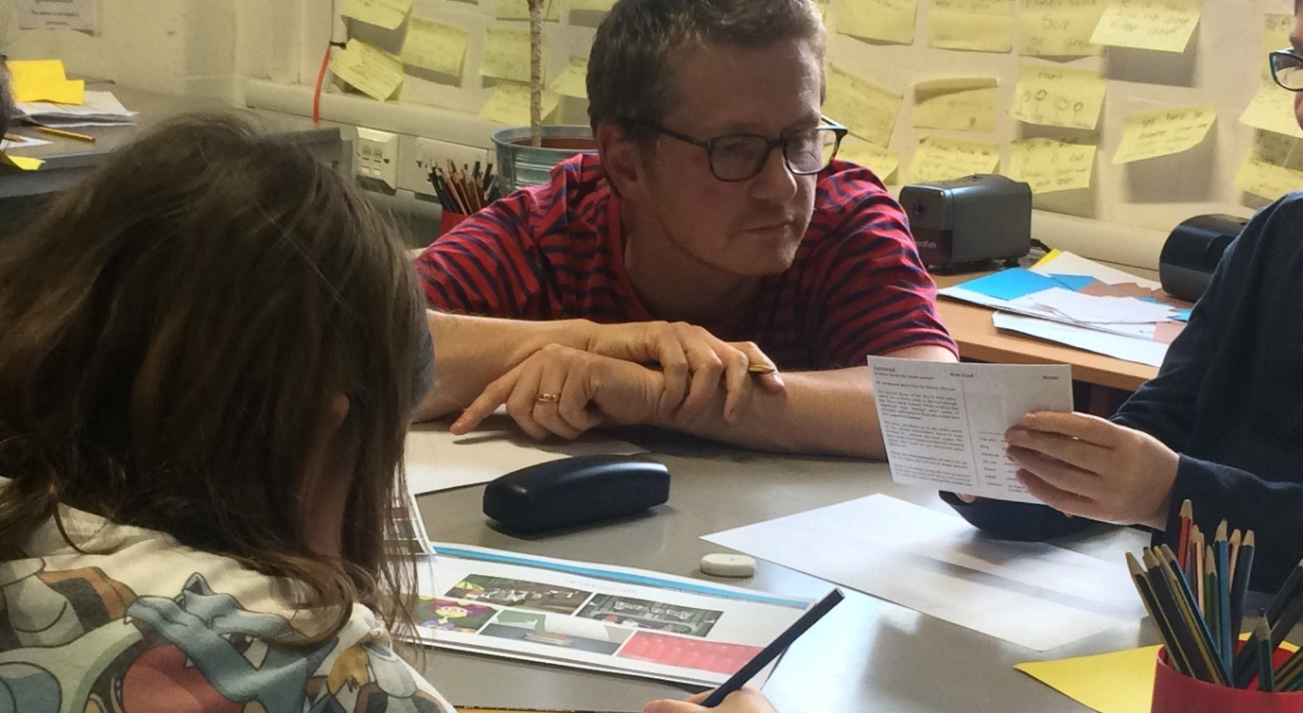
Robert At William Tyndale School working with students

Final Reflections:
Arts Award as a ‘hook’
Into Film felt that despite challenges with delivery and intensive support of schools, that Arts Award can act as a ‘hook’ with which to get more support, visits and resources for their school’s partnerships and engagement.
Arts Award and sustainability via ‘light touch’ resources
Supporting and encouraging teachers to sustainably deliver Arts Award is difficult as it is not a priority. Doing Arts Award via film club to achieve 45 explore and 47 discover entries is a challenge because of evidence gathering. Lunchtime club is working with a trained individual who is unpaid.
There is a difficulty is in the ‘light touch’ resource and teachers need too much support for this to be sustainable at the moment. Responses have been mixed and some may feel it will be difficult to do it again. Getting teachers out to do school tips is also challenging.
Solutions:
The way forward to implementing quality resources in schools to be used for sustainable repeat delivery of Arts Award perhaps lies in solidifying existing networks and considering social media such as Twitter as a way of promoting interest, progress and engagement with Arts Award and teachers to find out about what is going on and where.

LEAN
Lewisham Education Arts Network (LEAN) is the lead partner in the organisation of Lewisham Live Festival. LEAN has nurtured and led the Lewisham Live partnership to grow from a single music showcase to an ambitious four-week long music and dance festival with 12 shows, 9 partners, 2000 young performers and an audience of 4000. The Local Area Network has noted local interest in Arts Award in the area, but it became evident that direct support was needed to support further action. LEAN therefore proposed to utilize the festival as a vehicle to support Arts Award. They were particularly interested to see if it could increase Arts Award delivery in Lewisham Primary Schools. Additionally, they sought to explore how to best communicate Arts Award’s valuable addition to the curriculum and what structures needed to be in place to support partnerships between arts organisations and schools.
They did this by inviting participating schools to an introductory meeting. They offered free Arts Award Adviser training and paired each school with a Lewisham Live arts partner. Each school will have three days of support from an arts partner and is signing agreements with dates and requirements for the programme set in advance. The aim is to develop a final guide or flow chart, which demonstrates how festival participation can contribute to Arts Award.
LEAN is using trained advisers from the festival partner arts organisations to manage direct relationships with schools. They will plan the programme jointly with teachers, but the schools will register as new centres and deliver the awards themselves. The arts organisation’s main role is to ensure that the school uses the activity they were already undertaking as part of the festival to complete their Arts Awards. The plan is to demonstrate that ongoing work doesn’t need to be replicated, just captured differently and embedded alongside Arts Award.

LEAN has also enlisted two additional schools for a light touch “Arts Award introduction”, who will be invited to Arts Award events and have a face to face meeting to discuss training options for the future.
This programme is at an earlier stage in its delivery and this is reflected in the below.
Overcoming challenges:
Limited knowledge of Arts Award in borough: Upon consultation, LEAN found that many teachers were confusing Arts Award with Artsmark. They therefore ran an introductory meeting to explain Arts Award and administered evaluation forms to track the changes in teacher’s knowledge and perceptions. Teacher and arts organisations shared completed portfolios as examples. This open event meant that schools that do not usually participate in these programmes were able to meet LEAN and join as new partners.
Management one step removed: LEAN is referring schools onto arts partners who are managing the Live Lewisham elements. This slowed down the timeline as it took a good deal of chasing to confirm involvement, set meeting dates and confirm art forms. They overcame these issues by narrowing the choice for schools participating in the Arts Award strand to Live Voices or Live Dance. They also started matchmaking, so put schools into direct contact with a specific partner rather than giving them too much choice. Being one step removed meant it was also difficult to ensure that the concept of Arts Award was clearly being communicated. They therefore brought delivery partner together for a conversation to set clear expectations and plans.
Different staff members managing different strands: Lewisham Live staff representatives are not necessarily those leading the Arts Award strand. These delivering practitioners are not the ones at festival meetings so it was hard to communicate about the project with the relevant people. LEAN dealt with this by adding extra meetings with the appropriate staff, but that did mean that the timeline had to be shifted.
Staff changes: Due to staff changes, the arts partners do not have staff trained as Arts Award Advisors as was previously anticipated. This meant that additional training needed to be mapped into the timeline and budget.
Successes:
School’s interest: Lewisham Primary schools are showing much more interest in Arts Award, as proven by attendance at LEAN’s introductory session and a session held by Phoenix Community Housing. 11teachers attended and two schools immediately signed up after the first meeting. Arts Award Advisor training for teachers is being paid for by Phoenix Community Housing and is proving very popular, with 15 teachers signed up.
“Thank you for the support we've received from you and Miriam, and LEAN, to (almost) complete the Arts Award process with our group of children, who participated in Live Dance this year. the children have so enjoyed their time as learners, audience and performers and we're really proud of their achievements so far. We're seeing Miriam on 2 more occasions to get their Log Books all finished up and then, finally, to share their experiences with their peers. Very exciting!…we'd love to begin planning other ways we could incorporate Arts Award into our teaching and learning next academic year; it would be fantastic to see the same children go on to deepen their enjoyment and understanding of the Arts with an 'Explore' challenge, or allow some children newer to Arts to complete a 'Discover' award- or both!”
teacher -Predergast-Ladywell Primary School
Partner’s interest: The Lewisham Live partnership as a whole were keen to integrate Arts Award into their festival. Trinity Laban Conservatoire of Music and Dance and the Lewisham Music Service and Hub have taken a lead role in mentoring schools, but the programme is discussed with all partners at network meetings.
Final Reflections:
Testing out sessions before structuring resources:
This was something that worked well. St Augustine’s school worked well to create an inspiring format to achieve discover as part of the Lewisham Live festival. 35 children in a choir who were scheduled to perform at the Broadway attended tours with an employability focus as well as being involved in a tech rehearsal, which helped their understanding about the history of the venue. These aspects are to be reproduced in the new Lewisham Live Arts Award resource LEAN hopes to develop.

Training does work to create sustainability provided Arts Award is a priority.
The project managed to increase the training numbers from key partner organisations from the festival; (such as Laban) now have trained staff so this will form part of the sustainable offer.
The lead for singing at Lewisham Music- has also been trained. This will encourage the Music service to think about their offer and whether they can implement Arts Award as part of Lewisham Live Festival.

Orleans House Gallery
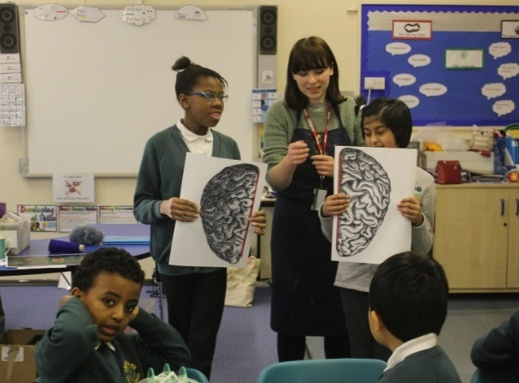
Orleans House Gallery (OHG) sought to explore how Arts Advisory Hubs can support teachers and schools to embed the arts in their curriculum. Through this programme they intended to create new Hubs, consult the teachers on how Arts Award can be embedded within existing activities and investigate how progression routes can be included. Having encountered a lack of knowledge around Arts Award and its benefits for young people, limited capacity from teachers and a series of one off projects without progression routes, they felt that working in partnership and forming Borough Arts Award hubs and advisory groups was the best way forward.
To extend this project, they combined it with an Art and Science project they were delivering with groups with learning disabilities at OHG. They engaged three primary schools in Richmond and Hounslow and consulted them on their interests in order to form slightly different strands for each of them.

For example, one partnership is with the school’s Art Coordinator and SEND lead to run the programme with their SEND unit, the Science Coordinator in another school wanted to look at more creative ways to teach science and the Head of another school is the main strong driver. This demonstrates how they took a bespoke approach in each school to find the right contact and approach.

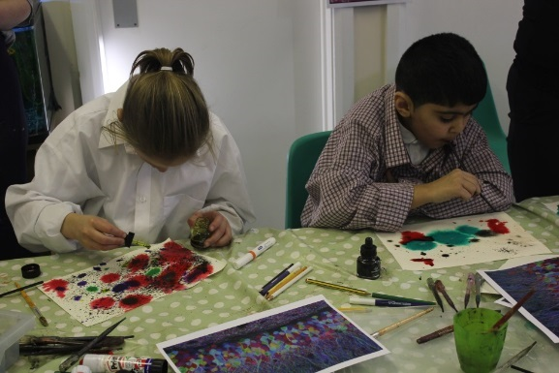
Two of the schools are particularly focused on progression and how they can move from Discover to Explore. To ‘embed’ across the curriculum, they were especially interested in engaging non-specialist Art teachers. The ‘hook’ of teaching science through art helped with this and they were joined by 23teachers (including the head) to run a CPD session and get their feedback on how they thought Arts Award could benefit their teaching and students.
Overcoming challenges:
School recruitment: Finding the right partners and Arts Award leaders within those schools took longer than anticipated. It was worthwhile, however, as OHG spent extra time building commitment with partners, understanding their needs and looking at how to embed Arts Award into teachers’ busy schedule. Holding teacher evenings and face to face conversations helped them plan and move forward.
Budget / Time: The logistics of setting up multiple Arts Award projects was challenging and time-consuming. By combining this project with the science Wellcome project OHG were able to extend their budget. They found they had been too ambitious on the number of young people they were offering the award to and in future, moderation costs need to be considered when working with schools. AND are supporting OHG to apply to the Arts Award Access fund to cover additional fees and they are working with the schools to consider different funding streams.
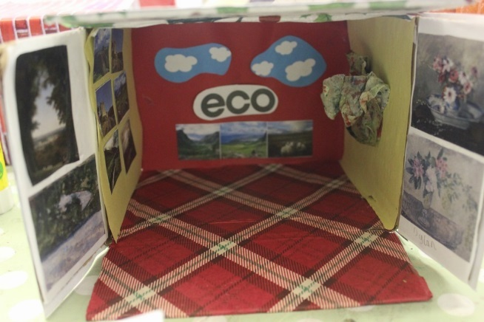
Sustainability: The amount of time OHG have dedicated to the process has made them question how schools can deliver this with less support in the future. Sharing the outcomes and benefits with school Heads will hopefully lead to more “buy in” and financial commitment.
Successes:
Enthusiasm of teachers: This project has relied upon and been successful, because of the backing and enthusiasm of the teachers. For example, the teacher at Crane Park managed to organise a whole staff CPD in which Orleans House Gallery and worked with every teacher for over an hour. She is now trying to convince her head to invest in Arts Award beyond the project and deliver future sessions for all pupils. All Head Teachers have been involved which has added to the motivation behind the project and importance people have put on it.
“Arts Award learning appeals to our very creative students who struggle with learning science the traditional way.” Teacher feedback form
“Arts Award encourages cross curricular lessons and act as an incentive for children to work hard”. Teacher feedback form
Involvement of Wider Museums and Galleries: Orleans House Gallery are involved in an informal ‘crisis in arts education’ group with other Heads of Learning from the big nationals including Tate, Royal Academy and the V&A. They are particularly interested in this project and want to see if it can make an impact in ‘embedding’ art in the curriculum.
“Arts Award supports my student’s learning, especially those who struggle with the academic subjects; it will help to give them an outlet and understanding through an alternative method of learning”. Teacher feedback form

“Arts Award is a very tangible way to bring other subjects to life, science, history and English especially.” Teacher feedback form
Considering sustainable options: All teachers are keen to work with OHG to explore and set sustainable options beyond the project. This includes possible progression options, working with transition groups, and sharing findings with senior staff members to discuss future investment. The creation of hubs and new partnerships will also be sustainable and beneficial to Richmond and Hounslow in the long run.
“A teachers Art Forum would give me opportunities to try new art techniques out and share my ideas“ Teacher feedback form

Final Reflections:
Teachers Hubs and Transition
Orleans house would like to explore teacher’s Hubs further, as they are a positive way of getting teachers together. Orleans House staff are thinking about using their existing summer club- to develop a free offer for schools to hook them in, as well as tackle transition in Arts Award which often affects attainment between levels when students move schools.
Orleans house would also like to explore whether Arts Award might work more sustainably if it had a stronger link with Arts Mark which could present another way of getting round to teachers.
There is also felt to be a need to find where Arts Award fits rather than trying to push it to schools. For example; teacher’s CPD worked well when the project was opened to link with existing work with the Wellcome collection, using creative work to teach science was a cross curricular focus that inspired teachers and made them more keen to do Arts Award as part of it.
Future avenues for exploration Included the potential to create an Arts Award resource box, and considering progression from Discover to Explore with partner schools as a mechanism for sustainability. There is also a possibility to create and explore SEND- focussed resources and Arts Award due to Orleans House expertise and existing partnerships, and this could perhaps link with teacher’s hub work too.

Conclusions

All delivery partners on the Local Area Development Programme raised a core broad theme at their final meeting that was then underpinned by given solutions for future delivery and interventions to make Arts Award work in Areas of low take up:
Funding and policy landscapes
Have meant that education and youth settings are facing challenging times, and that Arts Award is not seen as a priority for schools, even when they are engaging with significant cultural activity in the existing delivery. This resulted in difficulty in engaging teachers and schools, and sometimes high dependency relationships between schools, organisations and delivery partners in order to pay for and provide information and training on Arts Award and CPD.
Solutions included:
- Cross Borough Linkages and peer support between boroughs delivering Arts Award:
This was seen as encouraging shared best practice, and a wider pool of resources for schools, and organisations.

- Offering opportunities: ‘could ‘not ‘should’
Making CPD for teachers accessible, and fun were seen as key to ensuring they felt that they could include delivery in their existing tight schedules. For example, offering a private view, at a gallery or arts organisation with networking and drinks at twilight worked well in Redbridge and Waltham Forest for Chingford.

- Drawing out a cross curricular focus worked to make a case for doing Arts Award and working with more Arts and Culture:
Examples included, the Crafts Council, finding teachers working together with a cross curricular focus, and collaborating within CPD sessions, In Orleans House using the Wellcome collection work to make connections with Science, and at LEAN to engage teachers in an employability and arts inspiration focus looking at ‘behind the scenes’

- Celebrations and using parents and teachers as an ‘in’ for creating networks and resource sharing.
Into Film suggested that inviting schools and heads for celebration, getting good risk assessments and good info for trips together and then sharing showed powerful communication and garnered ‘buy in’ from organisations.
All delivery partners felt that creating online examples of assessment sheets so teachers can download and use examples and sharing resources actively across networks would work well. Overall, engaging parents and teachers in conversations together about delivery and celebrating their achievements is a powerful tool for repeat engagement and take up where resources are scarce and arts and cultural subjects not prioritised.

Appendices

Arts Award Discover and Explore case study: Film Club at William Tyndale Primary School
Discover [ Fantastic Mr Fox]
The advisers used the Into Film resource on Fantastic Mr Fox to successfully complete Arts Award Discover with their Film Club of 20 students from Year 4-6.
Part A:
The young people discussed all the different art forms involved in creating the film.
They analysed the film trailer [P.5.2 Into Film resource]
They wrote a review of the film [P.8 Into Film resource]
They filmed themselves presenting their reviews
They made a poster for the film [P.4. Extension, Into Film resource]
Part B:
They found out about the different roles involved in creating the film.
Part C:
They shared what they had learned with their class teacher and their parents.
Additional ideas that could be used for Discover or Explore Part A:
Create ‘Fantastic You’ badges and certificates [P.6.5. Into Film resource]
Write a rhyming song or rap [P.7.2 Into Film resource]
Role-play and film a news review [P.9 Into Film resource]
Create models and designs and ‘how to’ films for the Whack Bat game, or a new game that they have designed [P.10 Into Film resource]
Create puppets, or role-play characters from the film [P.11 Into Film resource]
Create own animation [P.11 Into Film resource]
Create a soundtrack [P.11 Into Film resource]
Explore [Making animations]
The children worked towards creating their own animations in a group to complete their Arts Award Explore. Since the children worked as a team and contributed to all elements of the process the teachers took photographs of all the work in progress and the children doing the work. They labelled the photographs in detail and created electronic folders for each child, with sub-folders for each part of Arts Award Discover. Film interviews and film-making exercises were also recorded as evidence.
An Arts Award Explore booklet had been created, and some of the pages completed, but not all.

Part A:
The children watched a number of animated films and wrote film reviews which they presented to their class teachers. They also recorded the presentations as if they were a radio show.
They worked as a group to discuss and plan ideas for creating their own animations and made storyboards to plan their animations.
They made posters for an animation called Sausage, with the animator who visited the club
Part B:
Into Film arranged for an animator to visit the film club. The children had prepared questions for the animator [these questions were added to their arts log along with photographs of the session]. The group had a discussion about what they learned which was recorded on a flip chart by the teachers. Each child had a copy of this record in their arts log.
The manager from the cinema visited the film club to talk about the cinema. Evidence was recorded as for the animator’s visit.
The teachers also used work that the children had done about their class visits to local museums and other cultural organisations towards evidence for Part B.
Part C:
The children hoped to have their completed animations ready for moderation, but they ran out of time, so for Part C they presented the characters and scenery that they made in order to create their film. The teachers took photos of the process which they labelled with detail. Photographs of the process and of the finished sets and characters were added to the arts logs.
Part D:
The children talked about film club in a special assembly, and showed the work they had done. They also invited their parents to a special sharing event at their film club. Invitations, photographs and a film of the presentation were added to the arts logs.

Arts Award Discover case study
Laycock School Nurture Group
Theme: Knuffle Bunny, by Mo Willems
The adviser worked with a nurture group of mixed age children with speech and language and communication difficulties, who are on the autistic spectrum or who are on the SEND register due to gaps in their learning.
They had been reading the book ‘Knuffle Bunny’ by Mo Willems. They read it every day for a number of weeks so that the children became familiar with the story, the language and the images. The children were able to confidently retell the story and identify their favourite parts.
They watched an animated version of the book, which enhanced their understanding of the story-line, setting and characterisation.
They watched a short interview with Mo Willems and then looked online to find other books he has written along with animated versions of the stories. They were excited to find two more Knuffle Bunny books with accompanying animations. Having watched the animations they asked if the books could be bought for their group.
To aid their immersion in the story the young people took part in a series of activities. They added evidence of these activities to their Arts Award Discover Arts Logs
Part A:
- Discussed all the arts activities that they like doing [they stuck some images of the activities in their Arts Logs and labelled them]
- Painted pictures of Knuffle Bunny [the paintings were added to their Arts Logs]
- Wrote book reviews using writing templates [the book reviews were added to their Arts Logs]
- Created freeze frames of their favourite scenes [photos were added to their Arts Logs]
- Created a group song about Knuffle Bunny [the song was added to their Arts Logs]
- Designed their own soft toys [the designs were added to their Arts Logs]
- Made their own soft toys [photos were added to their Arts Logs]
Part B:
- Identified facts about Mo Willems [they wrote the facts in their Arts Logs]
Part C:
- Told their Head Teacher about the things they had done [witness statements and photos were added to their Arts Logs]

A Knuffle Bunny PowerPoint booklet template was created as a prompt for Arts Award Discover. This template can be adapted and changed to suit other books or films. [See attached] Not all the pages need to be used, please see the Into Film Arts Award teacher guidance for more details.

Arts Award Discover case study
Vittoria Primary School
Lunch-time French club
Theme: The Blind Photographer
The children watched the film, The Blind Photographer
Part A:
They chose their favorite images from the film and stuck them in their Arts log
They wrote a film review for their school magazine and added it to their Arts Log.
They created a poster for the film, which they added to their arts Log.
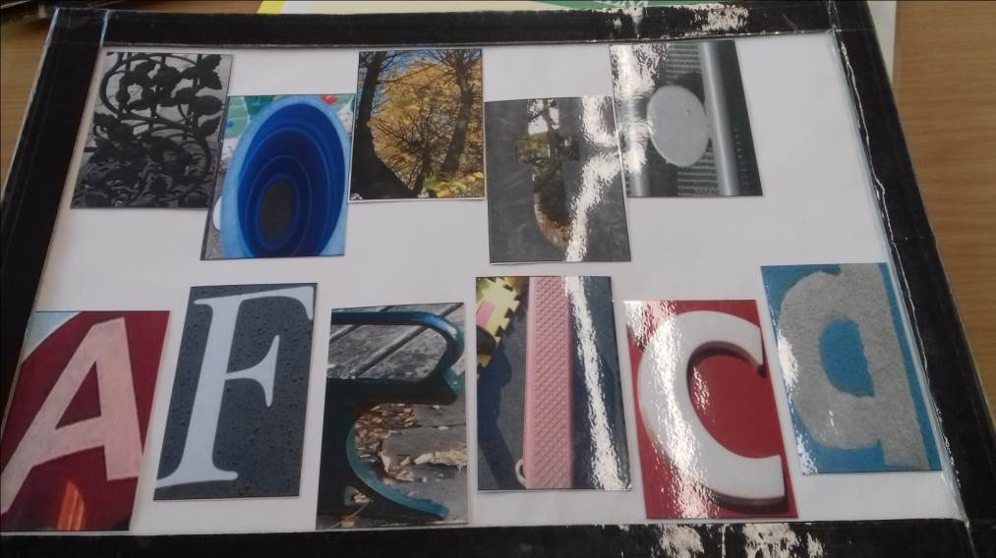
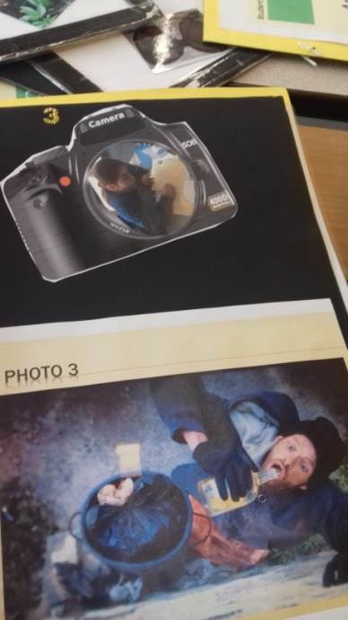
They then learnt about different kinds of cameras and explored the school environment, using cameras to identify letter shapes in the environment. They pooled their photographs and selected letters to make words connected with the film

Part B:
They found out about the work of French photographer, Robert Doisneau and created a timeline in the form of a clock, using keywords from his life. They compared his work to that of the Blind Photographer as portrayed in the film.
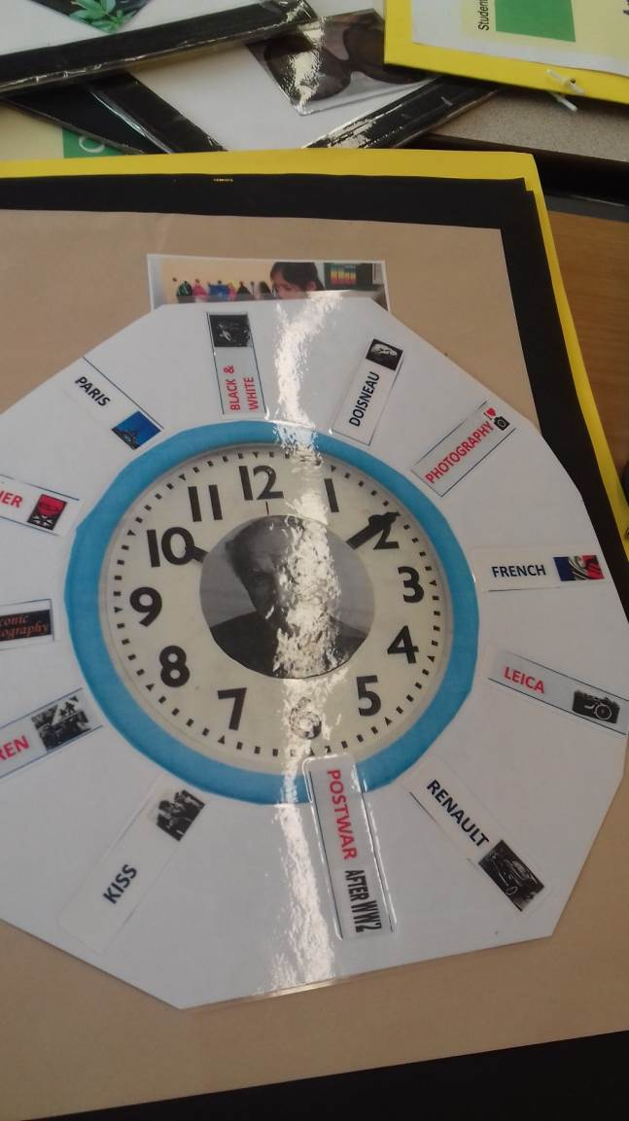
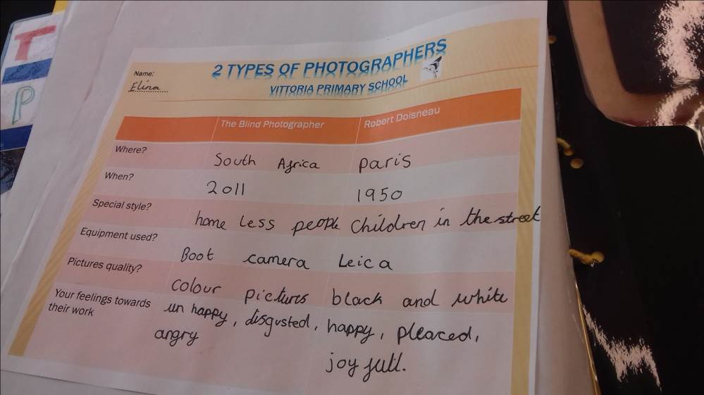

Part C:
They presented what they had enjoyed through doing the Arts Award to their group, in assembly and to a visiting project coordinator, who wrote them a letter of thanks which they stuck in their Arts Logs. They also wrote feedback for each other on post-it notes, which they stuck in their Arts Logs.

Discover and Explore Arts Award case study
Vittoria primary school film club
Theme: a year-long film-making project with the BFI

Throughout the year the children are keeping film club diaries. These effectively became their Arts Logs for Discover and Explore, along with the films that they made, which were kept on the school’s VLE. Artsbox was considered but not used, as the adviser did not have the capacity to upload all the children’s films to individual accounts. Photographs of the activities and all their planning work were stuck into the diaries and annotated.
The children designed their own set of emoticons to indicate how they felt about each activity.
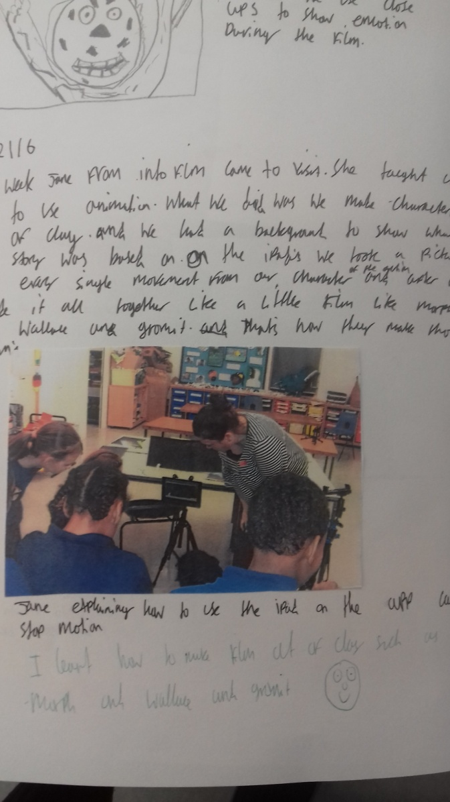
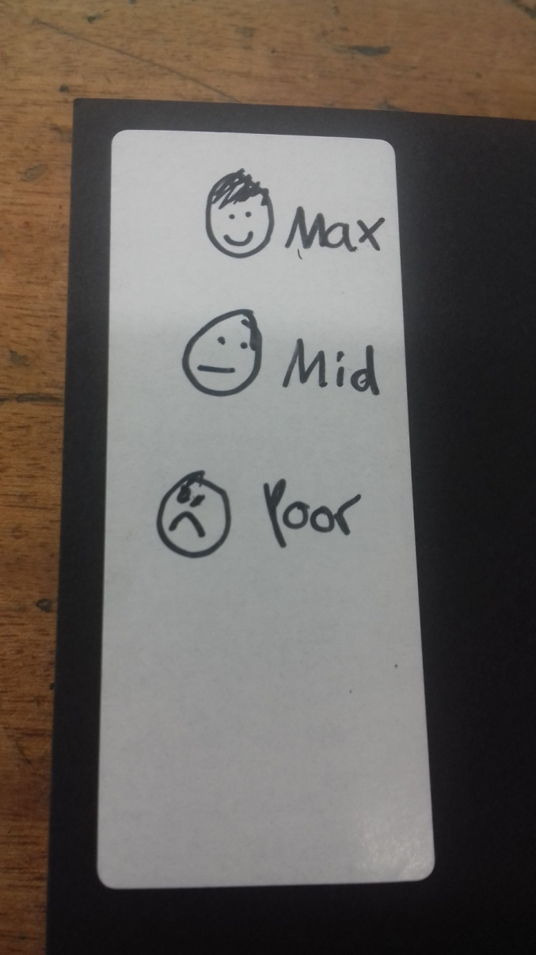

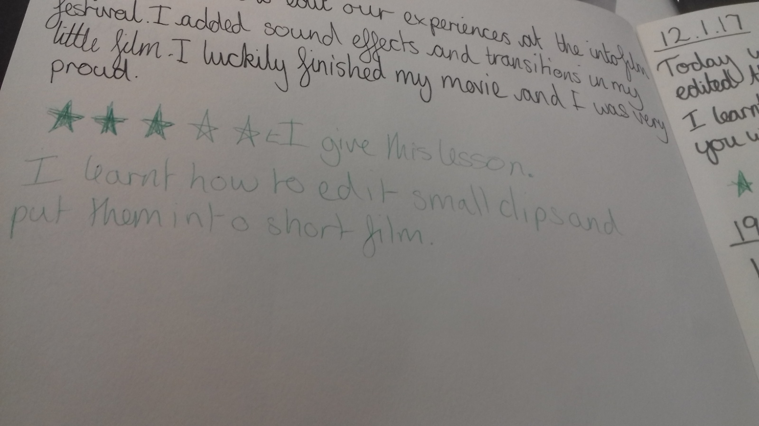
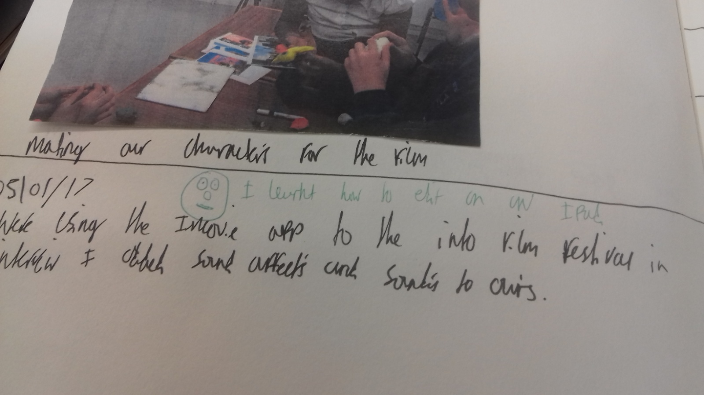
Arts Award Discover part A:
The children learned about different shots, wrote film reviews, and made little practice films in various genres

Discover part B:
They learned about the different roles involved in making films.
Discover part C:
They showed their film club diaries to their head-teacher and to their parents.
Explore part A:
They made story-boards, wrote scripts, designed characters
Explore part B:
They talked to film professionals, went to the London Art Fair, worked with the BFI and found out about the organisation
Explore Part C:
They made a short film, taking photos of the process and writing about it in their diary.
Explore part D:
They presented about the whole project in a school assembly, and again at a BFI celebration event

Arts Award Discover and Explore case study: Film Club at William Tyndale Primary School

Discover [ Fantastic Mr Fox ]
The advisers used the Into Film resource on Fantastic Mr Fox to successfully complete Arts Award Discover with their Film Club of 20 students from Year 4-6.
Part A:
The young people discussed all the different art forms involved in creating the film.
They analysed the film trailer [P.5.2 Into Film resource]
They wrote a review of the film [P.8 Into Film resource]
They filmed themselves presenting their reviews
They made a poster for the film [P.4. Extension, Into Film resource]
Part B:
They found out about the different roles involved in creating the film.

Part C:
They shared what they had learned with their class teacher and their parents.
Additional ideas that could be used for Discover or Explore Part A:
Create ‘Fantastic You’ badges and certificates [P.6.5. Into Film resource]
Write a rhyming song or rap [P.7.2 Into Film resource]
Role-play and film a news review [P.9 Into Film resource]
Create models and designs and ‘how to’ films for the Whack Bat game, or a new game that they have designed [P.10 Into Film resource]
Create puppets, or role-play characters from the film [P.11 Into Film resource]
Create own animation [P.11 Into Film resource]
Create a soundtrack [P.11 Into Film resource]
Explore [Making animations]
The children worked towards creating their own animations in a group to complete their Arts Award Explore. Since the children worked as a team and contributed to all elements of the process the teachers took photographs of all the work in progress and the children doing the work. They labelled the photographs in detail and created electronic folders for each child, with sub-folders for each part of Arts Award Discover. Film interviews and film-making exercises were also recorded as evidence.
An Arts Award Explore booklet had been created, and some of the pages completed, but not all.

Part A:
The children watched a number of animated films and wrote film reviews which they presented to their class teachers. They also recorded the presentations as if they were a radio show.
They worked as a group to discuss and plan ideas for creating their own animations and made storyboards to plan their animations.
They made posters for an animation called Sausage, with the animator who visited the club
Part B:
Into Film arranged for an animator to visit the film club. The children had prepared questions for the animator [these questions were added to their arts log along with photographs of the session]. The group had a discussion about what they learned which was recorded on a flip chart by the teachers. Each child had a copy of this record in their arts log.
The manager from the cinema visited the film club to talk about the cinema. Evidence was recorded as for the animator’s visit.
The teachers also used work that the children had done about their class visits to local museums and other cultural organisations towards evidence for Part B.
Part C:
The children hoped to have their completed animations ready for moderation, but they ran out of time, so for Part C they presented the characters and scenery that they made in order to create their film. The teachers took photos of the process which they labelled with detail. Photographs of the process and of the finished sets and characters were added to the arts logs.
Part D:
The children talked about film club in a special assembly, and showed the work they had done. They also invited their parents to a special sharing event at their film club. Invitations, photographs and a film of the presentation were added to the arts logs.

