QR Trail
Find out whether the venue has a written trail/Question and Answer worksheet – this can be your starting point for ideas of what to explore and include in your own trail. You can develop this further by including specific objects/areas/details that you particularly want them to explore.
When you have your questions/trail in mind here are step into involving QR codes:
- Set up a simple website with a different page for each ‘clue’
The website used at the AND forum was wordpress: https://wordpress.com/
- You don’t need to worry too much about the navigation of the website, however I have grouped the pages using the Menu tool so that visually I knew that the trail was ready – see below
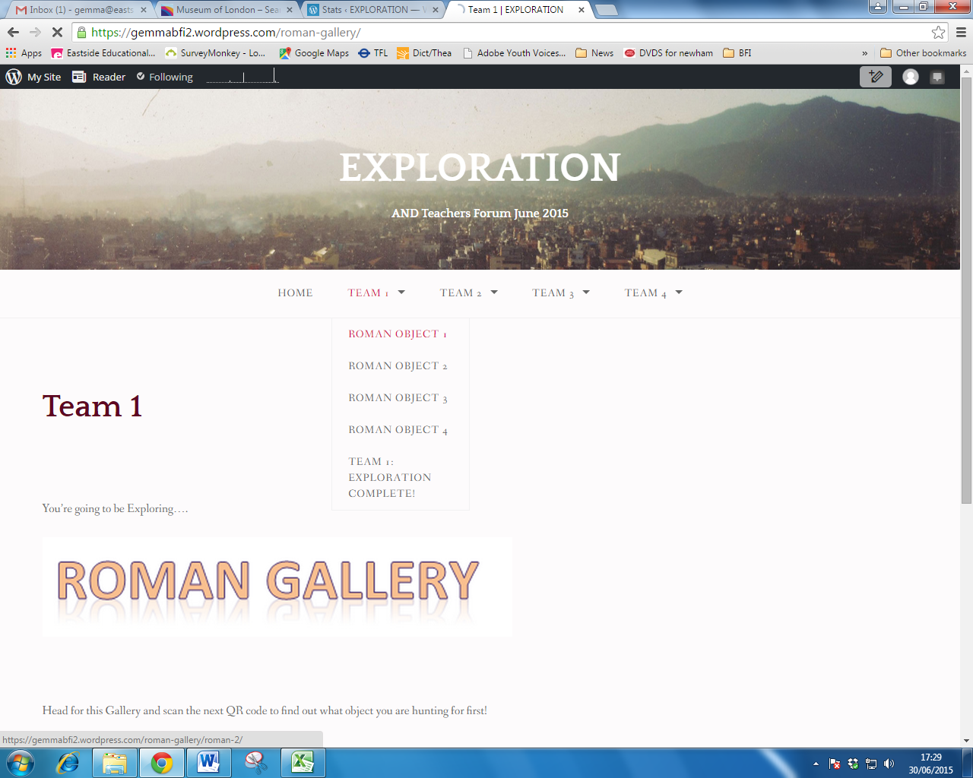
- When you have all of your pages, get a blank document ready to put the QR code on
- Copy the web address for the page that you was the QR code to take your students too
- Open up a New Tab and type in http://www.qrstuff.com/
- In section 1, make sure that the link is on Website URL.
In Section 2, paste your web address into the box
Be sure to click on a blank part of the page so that the website can generate the code
You will see a slight change in the QR code Preview to the left of the screen
Click on Download QR code and it will give you the option of where to save the file
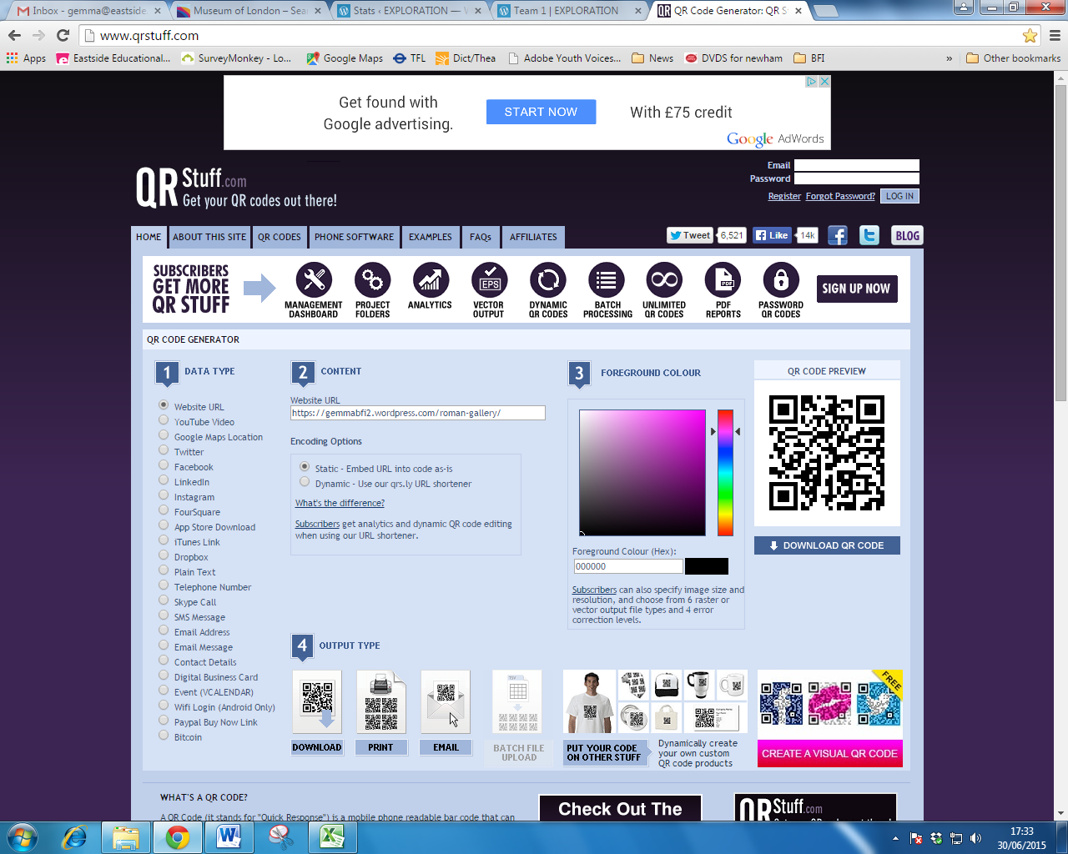
- Once saved you can insert it in your word document – double check it at this point
- Continue this process until all of the pages have a QR code associated with them and print for your students to explore!

In term of APPs, for the AND Forum we used ‘QR Code Reader by Scan’ but anyone would work and a couple are free!

The QR code apps that tend to charge enable you to create QR codes on the device as well – if you wanted to extend this activity and have the budget to do so!

