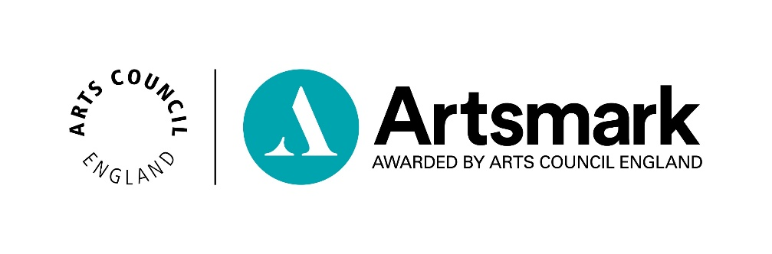
Statement of Commitment
Application paperwork 1 of 2

Name of school/education setting
DfE number | _ _ _ / _ _ _ _

Support
We are here if you need us.
Use this template to draft and finalise your Statement of Commitment.
Our submission process has changed. You must submit your Statement of Commitment online - we no longer accept email submissions. Please read our Submission Guidance for the steps to follow.
Download our guidance on how to complete your Statement of Commitment: artsmark.org.uk/resources and get in touch with your Bridge organisation, who offer support throughout your Artsmark journey.

Tips

- We strongly recommend you use as much of the available word counts as possible when drafting your responses, to give us as much information as you can about the plans for your Artsmark journey
- Artsmark cannot provide feedback on draft submissions. If you need feedback on your Statement of Commitment before submitting it, please contact your Bridge organisation, their details are on our website here
- We expect settings to submit their Statement of Commitment within three months of attending their Development training with their Bridge organisation

Context – up to 150 words
Describe the context of your school or education setting (for example your phase of education, establishment type, location, number on roll and so on).
(Enter your answer here)

Question 1 – up to 500 words
How do arts and culture currently play a role within your setting’s strategic values?
(Enter your answer here)

Question 2 – up to 500 words
How and why will your Artsmark journey contribute to the priorities in your strategic improvement plan?
(Enter your answer here)

Question 3 – up to 500 words
Looking at the Artsmark criteria, where does your setting currently have strengths and where would you like to develop?
(Enter your answer here)

Question 4 – up to 500 words
What are the goals and ambitions for your Artsmark journey and what steps will you take to achieve these?
(Enter your answer here)

Question 5 – up to 500 words
What support will you need and what resources will you commit to achieve your goals and ambitions?
(Enter your answer here)

Question 6 – up to 500 words
How will you know you have achieved your goals and ambitions? What will success look like and how will you evidence it in your Statement of Impact?
(Enter your answer here)

Approval
Click the box to agree to the statements and enter the name and date this was approved.
☐ I confirm that I have read, approved and endorsed the Statement of Commitment and agree to oversee and support the Artsmark journey
☐ I agree to the Artsmark Award Terms and Conditions
(These are available online at artsmark.org.uk/terms-and-conditions)

Headteacher Name:

Date:

☐ I confirm that I have read, approved and endorsed the Statement of Commitment and agree to oversee and support the Artsmark journey
☐ I agree to the Artsmark Award Terms and Conditions
(These are available online at artsmark.org.uk/terms-and-conditions)

Chair of Governors Name:

Date:

Checklist
Make sure you’ve checked the following before you submit online:
☐ My answer to the Context question has no more than 150 words
☐ My answers to Questions 1-6 have no more than 500 words each
☐ I have not included any additional information or evidence such as images, media, hyperlinks, or web links in my answers
☐ The Headteacher and Chair of Governors (or where these positions don’t exist,
persons of equivalent levels of responsibility) have approved this document.

Ready to submit?
You should submit your Statement of Commitment within three months of attending your Artsmark Development training.
Once you’ve finalised your answers and have completed the checklist above, you are ready to submit online. We no longer accept submissions by email.
Copy and paste your answers into your online Statement of Commitment form using the unique web link we emailed to you. Can’t find your link? Get in touch to request it by emailing artsmark@artscouncil.org.uk

