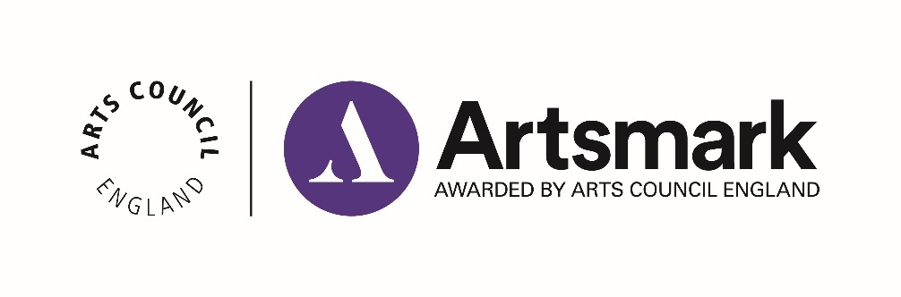

Statement of Impact
Application paperwork 2 of 2

Name of school/education setting
DfE number | _ _ _ / _ _ _ _

Support
We are here if you need us.
Use this template to draft and finalise your Statement of Impact.
Our submission process has changed. You must submit your Statement of Impact online - we no longer accept email submissions. Please read our Submission Guidance for the steps to follow.
Download our guidance on how to complete your Statement of Impact: artsmark.org.uk/resources and get in touch with your Bridge organisation, who offer support throughout your Artsmark journey.

Tips

- We strongly recommend you use as much of the available word counts as possible when drafting your responses, to give us as much information as you can about the impact of your Artsmark journey
- We recommend you use as much of the time available to you as possible before submitting your Statement of Impact. If you are unsure of your deadline, please contact us at artsmark@artscouncil.org.uk
- Artsmark cannot provide feedback on draft submissions. If you need feedback on your Statement of Impact before submitting it, please contact your Bridge organisation, their details are on our website here

Context – up to 150 words
If there have been changes to the context of your school or education setting since the submission of your Statement of Commitment, please describe them here.
(Enter your answer here)

Question 1 – up to 500 words
Reflecting on your Statement of Commitment and the Artsmark criteria, what was successful in your Artsmark journey and how did you achieve this?
(Enter your answer here)

Question 2 – up to 500 words
What challenges did you face and how did you overcome them? Were there any differences from your original plans and how did you implement them?
(Enter your answer here)

Question 3 – up to 500 words
What impact has the Artsmark journey had on your children and young people and how can you evidence this?
(Enter your answer here)

Question 4 – up to 500 words
What impact has the Artsmark journey had on your staff, leadership team and wider community and how can you evidence this?
(Enter your answer here)

Question 5 – up to 500 words
How has your Artsmark journey influenced change to your strategic values and the priorities in your strategic improvement plan?
(Enter your answer here)

Question 6 – up to 500 words
What are your future goals and ambitions for developing the role of arts and culture in your setting?
(Enter your answer here)

Approval
Click the box to agree to the statement and enter the name and date this was approved.
☐ I confirm that I have read, approved and endorsed the Statement of Impact and agree that it represents an accurate evaluative account of the Artsmark journey

Headteacher Name:

Date:

☐ I confirm that I have read, approved, and endorsed the Statement of Impact and agree that it represents an accurate evaluative account of the Artsmark journey

Chair of Governors Name:

Date:

Checklist
Make sure you’ve checked the following before you submit online:
☐ If applicable, my answer to the Context question has no more than 150 words
☐ My answers to Questions 1-6 have no more than 500 words each
☐ I have not included any additional information or evidence such as images, media, hyperlinks or weblinks
☐ The Headteacher and Chair of Governors (or where these positions don’t exist,
persons of equivalent levels of responsibility) have approved this document

Ready to submit?
You must submit your Statement of Impact within two years of submitting your Statement of Commitment.
Once you’ve finalised your answers and have completed the checklist above, you are ready to submit online. We no longer accept submissions by email. Copy and paste your answers into your online Statement of Impact form using the unique web link we emailed to you. Can’t find your link? Get in touch to request it by emailing artsmark@artscouncil.org,uk

