Consent and Healthy Relationships
Teaching for Creativity

Student Workbook

Name

Through class discussion, poetry and your own creative writing, we will explore the characteristics of healthy and unhealthy relationships. You will work together to examine and communicate what a caring and respectful relationship looks like, and will further your exploration on what consent means for them and the issues surrounding consent.

Starter

What does a relationship mean to you?

What words would you use to describe a relationship?

Friend or Foe?

See
What did you see?

Think
What did it make you think?

Wonder
What questions does it raise for you?

What did you notice that seemed like a healthy or unhealthy way of relating?

What can you say about the respect that was shown in the clip?

What can you say about shared interests or honesty?

At First Glance by Thembe Mvula

I WILL NOT APOLOGISE

for being bold and strong, passionate, bright and wrong.
I display nothing delicate outwardly,
even though my inner battles are fought quietly the words I let drip from my mouth
and evaporate into your ears undress the more I speak to you, conveying nothing but naked truth.

I won’t attempt to lure you with my looks,
I won’t gimmick you with flirtatious gestures, Or charm you with windy words,
I expect the same in return.
Over time I have come to learn
that first impressions are as finite as love at first site.

So show me your ugly, your sentimental, your messy, your blunt, your just plain silly. Show me your weak, your indecisive,
your cheek, your strange, your human- because that’s all there is to me
and these bones which frame my flaws
Holding up these walls I keep To hide a heart which somehow
always seems to find its way to my sleeve.

White wash the image you first painted of me, and if you dare to love this bird, rare
as rare birds with broken wings come Be sure to listen to her song
She doesn’t sing it for just anyone

At First Glance by Thembe Mvula
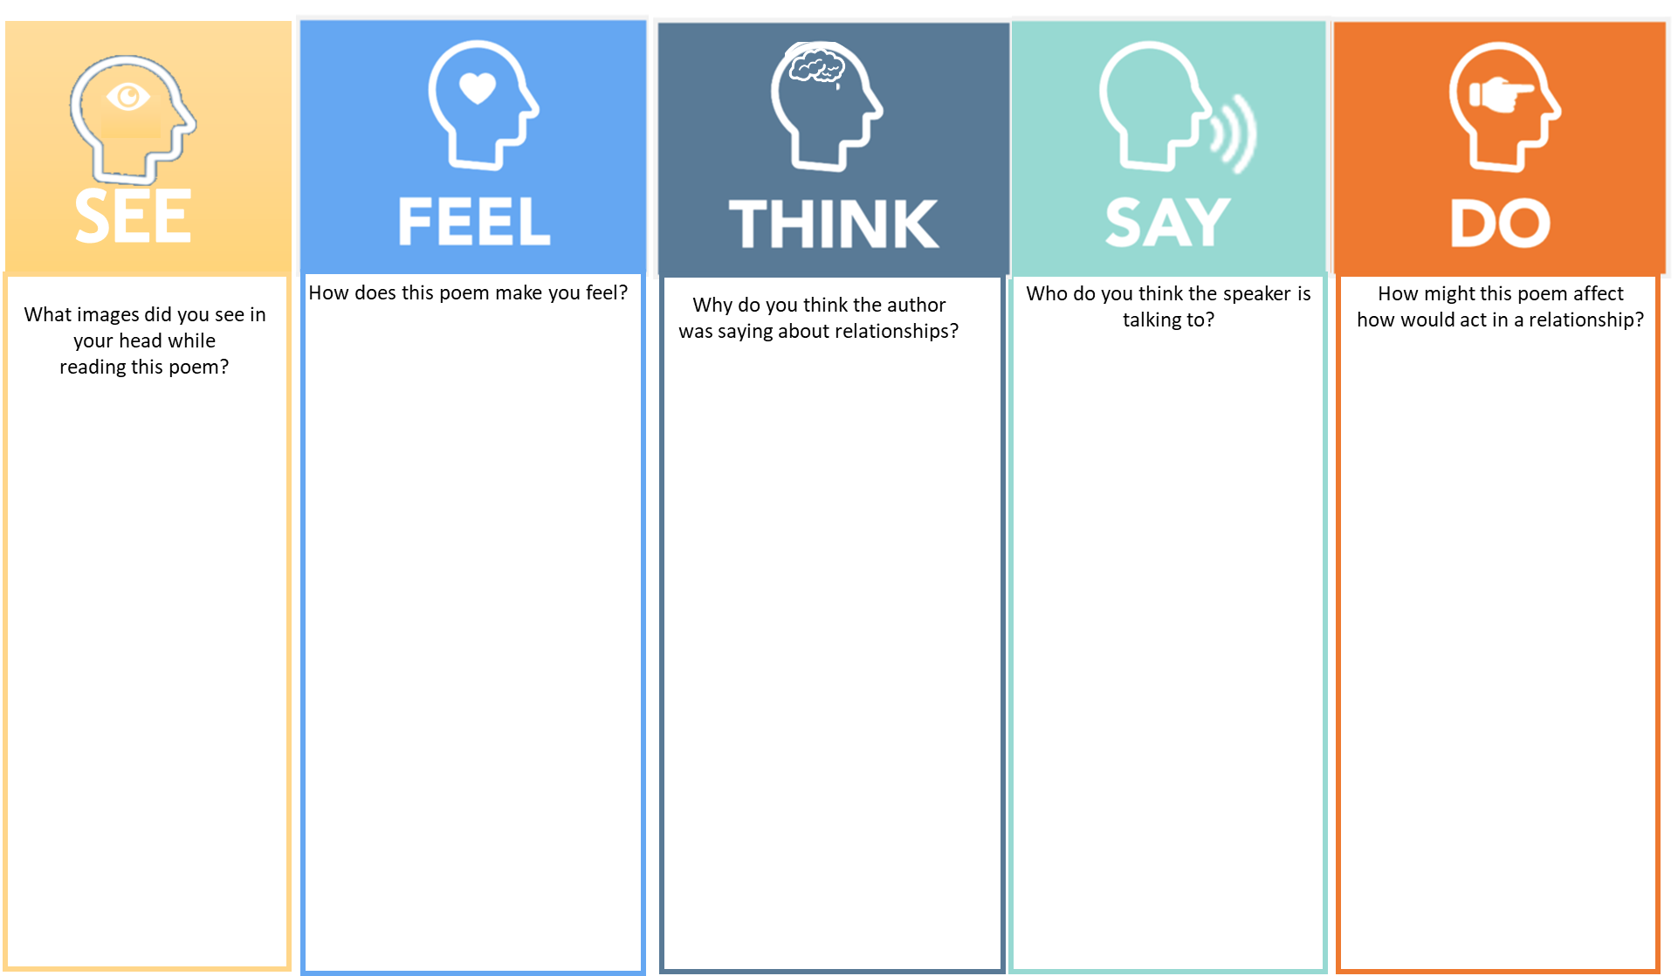

Relationships in Couplets

Write 4 lines to describe the characteristics of a healthy relationship you value for yourself.

Healthy vs Unhealthy Friendships

- Why is it important to look out for signs of unhealthy and healthy relationships?

- What has it made you think about the unhealthy signs we’ve noted?

- Why do you think it’s important to identify or name these characteristics?

- What assumptions are we challenging here?

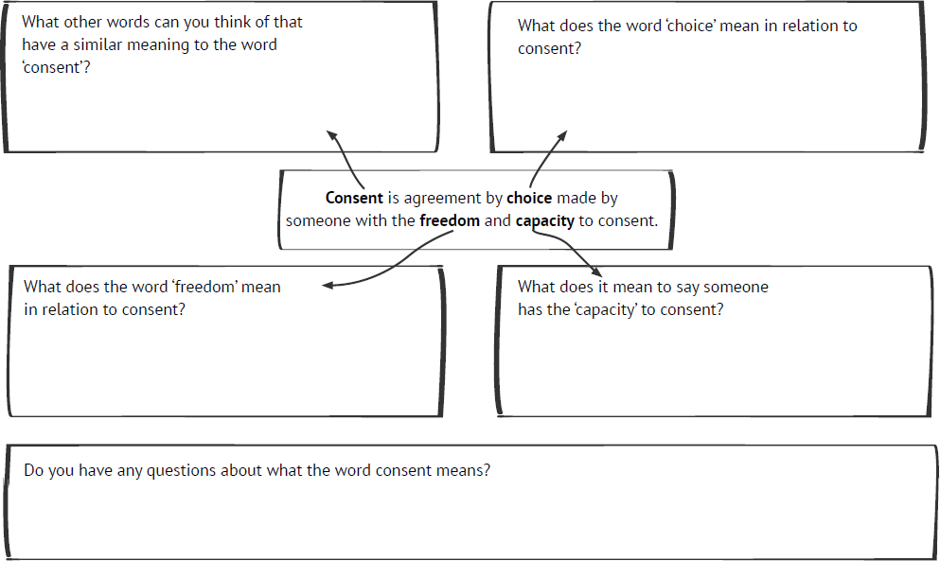Consent Is by Thembe Mvula

Consent is a smile on my face and a vibrantly vocal yes Consent is not zipping my lips with arms folded into my chest.

Consent is my hands held out wide, inviting affection
Consent is not wearing certain clothes out of seeking attention.

Consent is dressing how I wish and not being pestered
Consent is not exchanging my discomfort for another’s pleasure.

Consent is having a clear head whilst seeking permission from you Consent is not piling on pressure until my requests come true.

Consent is communication, respect and listening Consent is not being awkward, difficult, or boring.

Consent Mind Map

Non-verbal Cues

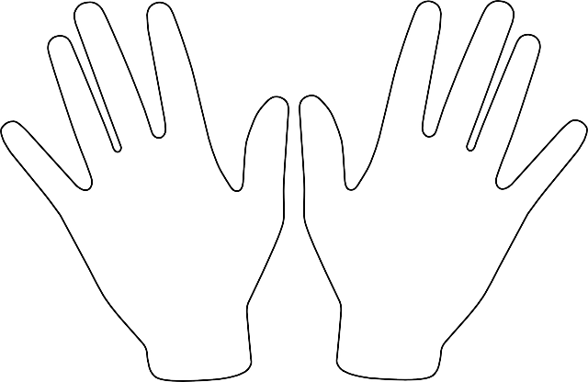Along each finger, write how people behave when they are happy with what someone is suggesting or doing

write an example on each finger of how you would let someone know when you don’t like (or no longer like) what someone is suggesting or doing?

Non-verbal Cues

In groups, organise all your finger ideas into three categories:

How people show with their words…
How people show with their facial expressions…
How people show with their body language..

Relationships in Couplets

Write 4 lines on what consent is for you

Write 4 lines on what consent is NOT

Final Reflection Questions

  - How did you find that short burst creative writing activity?

  - Reflecting on these sessions, how do you find the idea of giving or seeking consent and permission?

  - What has it made you think about respecting other people’s boundaries?

  - What further questions does it make you want to ask?

Workbook created by Brian Reeve-Hayes, PSHE Specialist at King's Lynn Academy

This workbook accompanies the Teaching for Creativity Key Stage 3 resource
Consent and Healthy Relationships
created by A New Direction in collaboration with the School of Sexuality Education

anewdirection.org.uk/teaching-for-creativity

