Research material for students

Who was Walter Rodney?
The bookshop was originally opened in the front room of the Huntleys’ home, before moving to commercial premises in Chignell Place, west Ealing, in 1974. The first book to be published by Bogle-L'Ouverture was called The Groundings With My Brothers by Walter Rodney, later described by academics as the ‘most influential Black Power text in the Caribbean’.
Rodney was a Guyanese academic historian, political activist and author who was an important figure in Caribbean politics. Rodney gave informal lectures on African history to groups of students and working-class Rastafarians, informing them of the intellectual, sociological and military prowess of ancient African civilisations.
On 13 June 1980, at the age of 38, Walter Rodney was assassinated by agents of the Burnham government in Guyana who opposed his political activity. The Huntleys helped keep his legacy alive by renaming their bookshop the Walter Rodney Bookshop and organising events in his name.
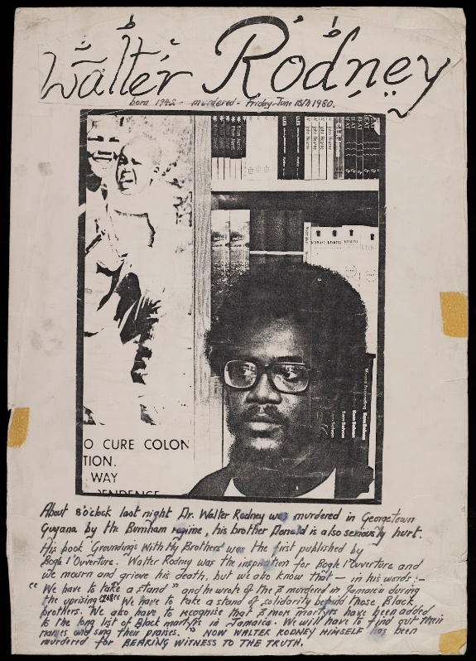

Image: LMA/4462/C/01/109B
What was the aim of the bookshop?
The bookshop became a focal point for black academics and artists visiting London from around the globe. Sales catalogues gave people access to a variety of titles sourced from America and the Caribbean that mainstream bookshops didn’t sell.
The life of the bookshop was intertwined with the concerns of the community and reflected their problems, achievements and ambitions. A key aim was to promote positive representations of black people, to fight back against the negative stereotyping and racism that was rife in England.
Sales catalogues gave people access to a variety of titles sourced from America and the Caribbean that mainstream bookshops didn’t sell.
Between 1982 and 1995, Bogle-L'Ouverture Publications joined with New Beacon Books and Race Today Publications to organise a series of book fairs. The fairs brought together publishers, political activists and artists from Africa, Asia, the Caribbean, North America and Europe to a forum where ideas were exchanged and work was showcased. Over six thousand people attended the first one.
It was a meeting place for the community; the Huntleys participated in many of the significant grassroots campaigns for racial and social justice that occurred on the national and international scene including:
- the black supplementary schools movement of the 1960s and 1970s
- the Black Parents Movement which campaigned against the controversial 'Sus' laws and organised legal defence for black and Asian people arrested during the Southall riots of 1979
- the New Cross Massacre Action Committee
The Huntleys organised the 1981 Black People's Day of Action march that attracted 20,000 black Britons from all over the country and was the largest protest march of black Britons to take place in Britain.
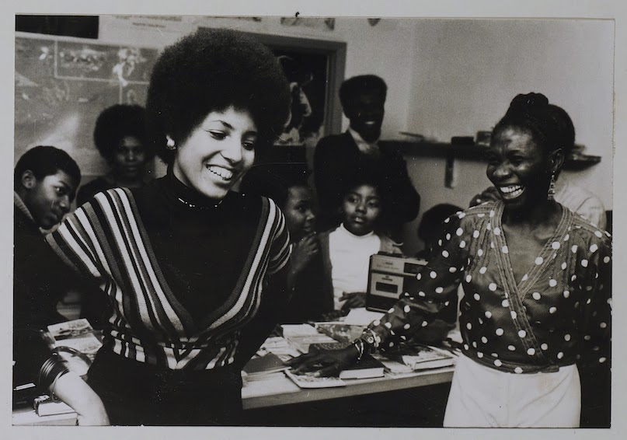

Image: Inside the bookshop, LMA/4462/F/01/03/005

Why was the shop attacked?
Eleven attacks took place on the bookshop between 1977-1983. Jessica Huntley recollects that the attacks on the bookshop were threatening and included intimidation and violence. Attacks such as these on black community bookshops were the manifestations of racist and fascist activity that targeted homes, businesses, meeting places, property and people, sometimes carried out by members of the National Front and the Ku Klux Klan.

What did the mainstream news say about the attacks?
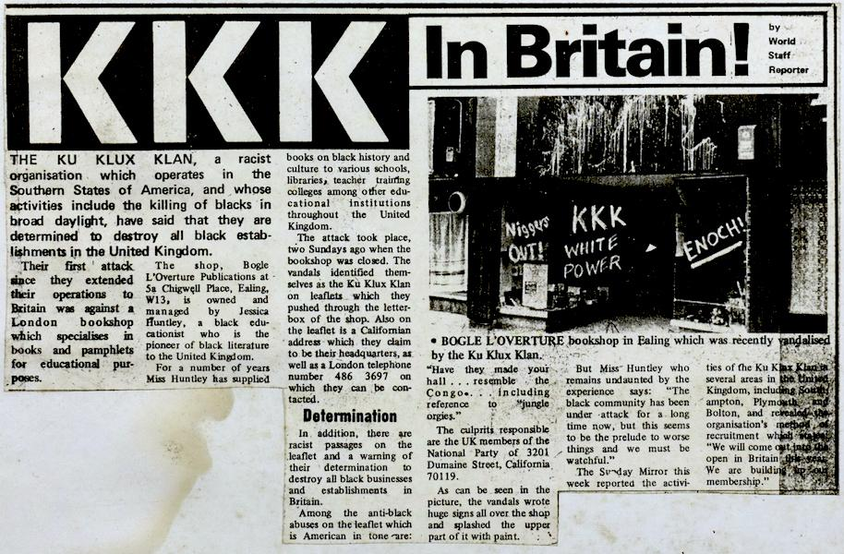
This and following clippings: LMA/4462/F/01/03/007
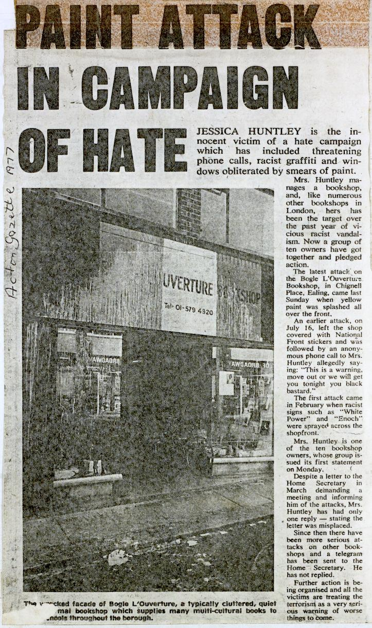
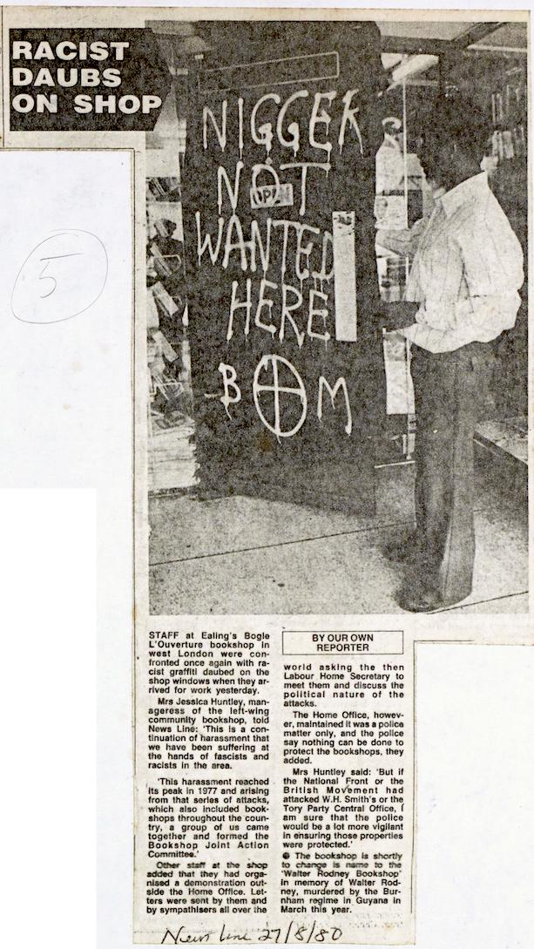

The final newspaper clipping is an article from News Line, published on 27th August 1980. It reads:
Other staff at the shop added that they had organised a demonstration outside the Home Office. Letters were sent by them and by sympathisers all over the world asking the then Labour Home Secretary to meet them and discuss the political nature of the attack.
The Home Office, however, maintained it was a police matter only, and the police say nothing can be done to protect the bookshops, they added.
Mrs Hutley said: ‘But if the National Front or the British Movement had attacked W.H. Smith’s or the Tory Party Central Office, I am sure that the police would be a lot more vigilant in ensuring those properties were protected.’
Why do you think Jessica Huntley feels W.H. Smith or the central office of a political party might be treated differently to the Huntley’s bookshop?

What did they publish?
Bogle-L'Ouverture published books mainly by black writers, including well-known poets such as Linton Kwesi-Johnson, Lemn Sissay and Valerie Bloom. Writers often participated in poetry readings and performances at the bookshop – it became a venue for workshops, readings and lectures.
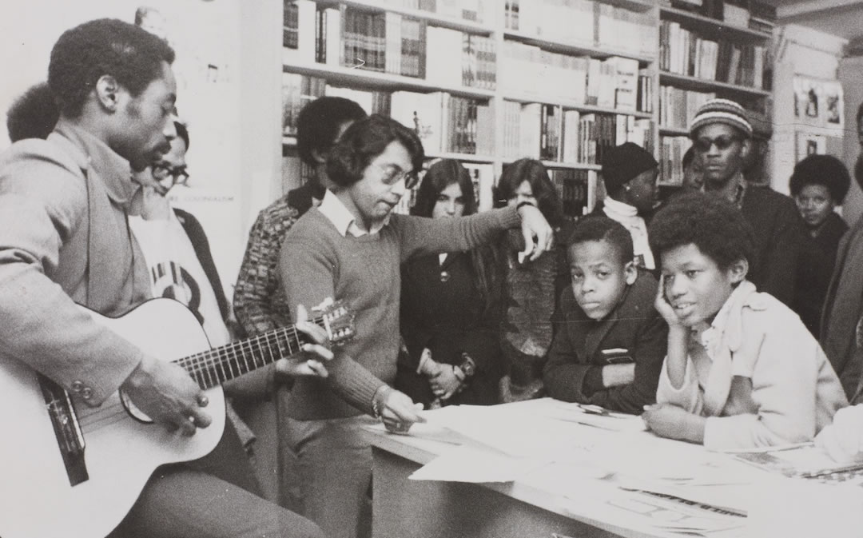
Activities at the bookshop, LMA/4462/F/01/03/005

